**Mobile App Development Lab Manual**

**PROGRAM 1**

Aim:

        To develop a Simple Android Application that uses GUI components, Font and Colors.

**Procedure:**

**Creating a New project:**

* Open IDE and then click on **File -> New -> Android Application Project.**

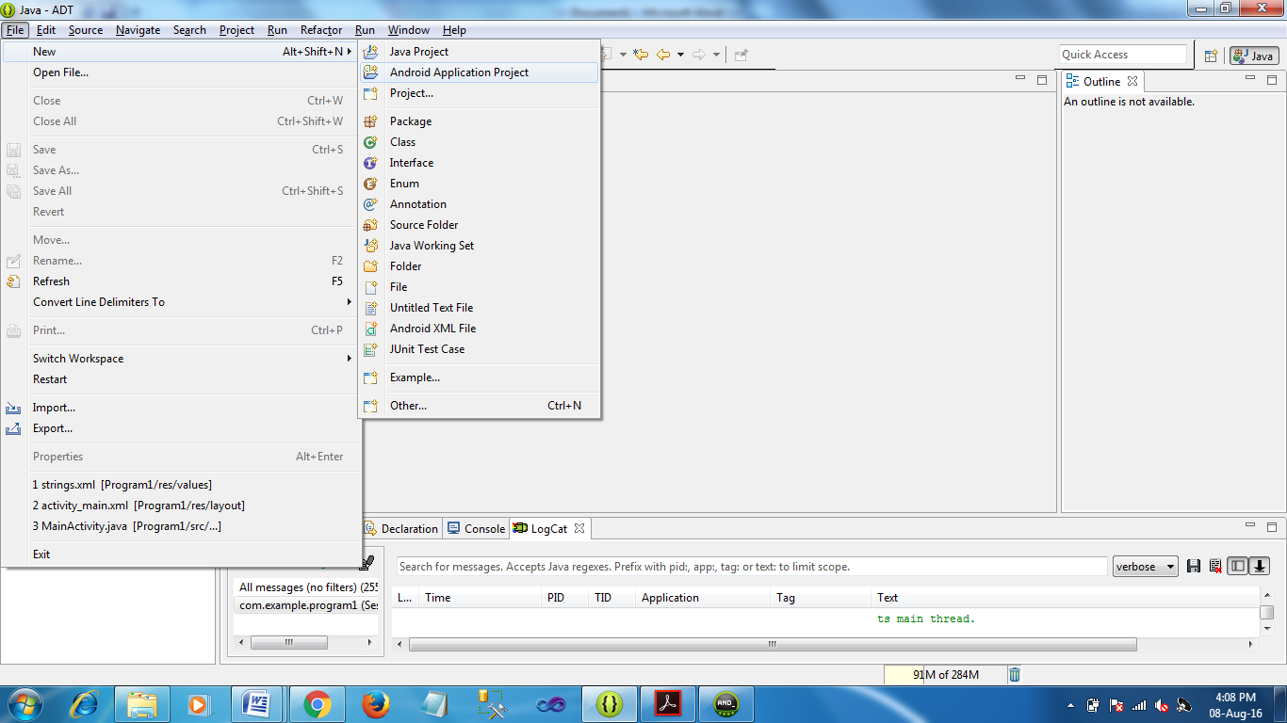

* Then type the Application name as “**Program1″** and click **Next.**
* Then click **Next.**
* Then click **Next.**
* Then select **Blank Activity** andclick **Next.**
* Finally click F**inish**.
* It will take some time to build and to load the project.
* After completion it will look as given below.

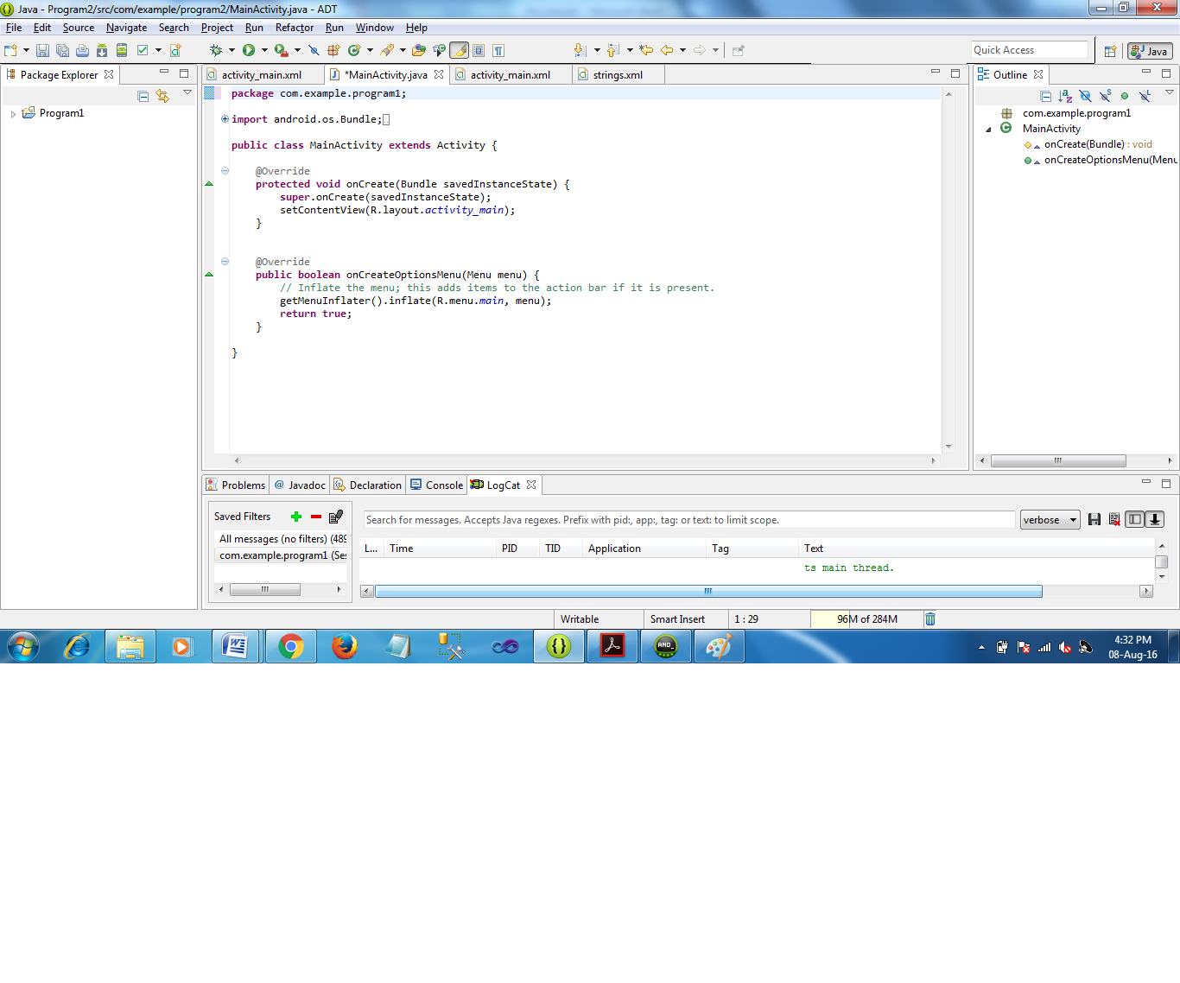

**Designing layout for the Android Application:**

* Click on **Program1 -> res -> layout -> activity_main.xml.**
* Now go to XML code editor.
* Then delete the code which is there and type the code as given below.

**Code for Activity_main.xml:**

|  |
| --- |
| <LinearLayout xmlns:android=*"http://schemas.android.com/apk/res/android"*  android:orientation=*"vertical"*  android:layout_width=*"match_parent"*  android:layout_height=*"match_parent"*>    <TextView  android:id=*"@+id/textView"*  android:layout_width=*"match_parent"*  android:layout_height=*"wrap_content"*  android:layout_margin=*"30dp"*  android:gravity=*"center"*  android:text=*"@string/hello_world"*  android:textSize=*"25sp"*  android:textStyle=*"bold"* />    <Button  android:id=*"@+id/button1"*  android:layout_width=*"match_parent"*  android:layout_height=*"wrap_content"*  android:layout_margin=*"20dp"*  android:gravity=*"center"*  android:text=*"@string/font_size"*  android:textSize=*"25sp"* />    <Button  android:id=*"@+id/button2"*  android:layout_width=*"match_parent"*  android:layout_height=*"wrap_content"*  android:layout_margin=*"20dp"*  android:gravity=*"center"*  android:text=*"@string/color_size"*  android:textSize=*"25sp"* />    </LinearLayout> |

**Defining strings for the Android Application:**

* Click on **Program1 -> res -> values -> strings.xml.**
* Now go to XML code editor.
* Then delete the code which is there and type the code as given below.

**Code for strings.xml:**

<?xml version=*"1.0"* encoding=*"utf-8"*?>

<resources>

<string name=*"app_name"*>Program1</string>

<string name=*"action_settings"*>Settings</string>

<string name=*"hello_world"*>Hello world!</string>

<string name=*"font_size"*>Change font size</string>

<string name=*"color_size"*>Change color</string>

</resources>

* Now click on Design of **Activity_main.xml** and your application will look as given below.

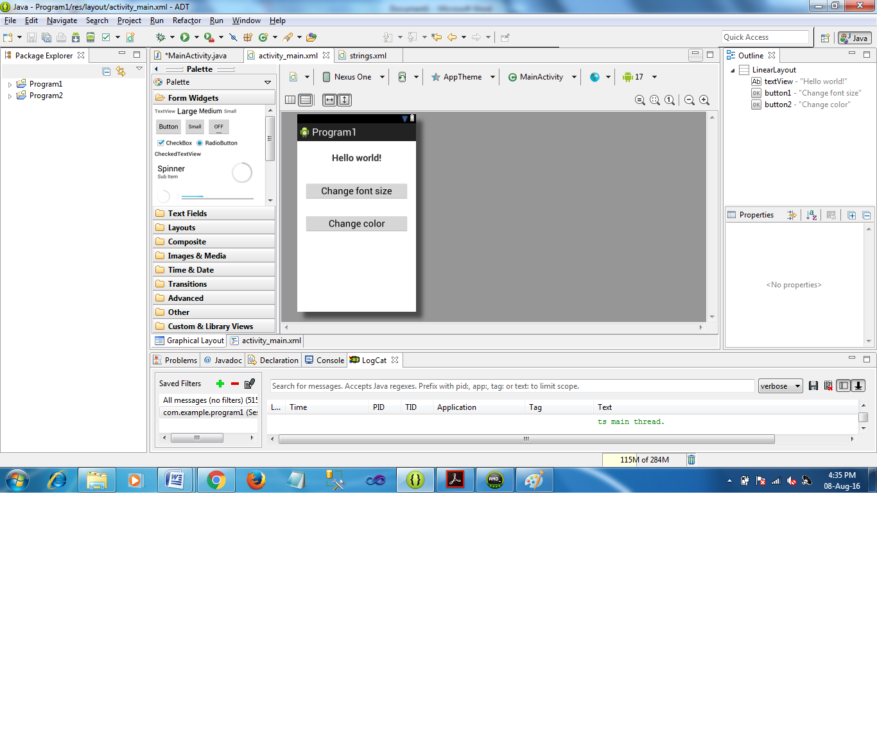

* So now the designing and defining part is completed.

Java Coding for the Android Application:

* Click on **Program1 -> src -> com.example.program1 -> MainActivity.**
* Then delete the code which is there and type the code as given below.

**Code for MainActivity.java:**

|  |
| --- |
| **package** com.example.program1;  **import** android.os.Bundle;  **import** android.app.Activity;  **import** android.graphics.Color;  **import** android.view.Menu;  **import** android.view.View;  **import** android.widget.Button;  **import** android.widget.TextView;  **public** **class** MainActivity **extends** Activity {    //Code Start  **int** ch=1;  **float** font=30;  //Code End    @Override  **protected** **void** onCreate(Bundle savedInstanceState) {  **super**.onCreate(savedInstanceState);  setContentView(R.layout.*activity_main*);    //Code Start  **final** TextView t= (TextView) findViewById(R.id.*textView*);  Button b1= (Button) findViewById(R.id.*button1*);  b1.setOnClickListener(**new** View.OnClickListener() {  @Override  **public** **void** onClick(View v) {  t.setTextSize(font);  font = font + 5;  **if** (font == 50)  font = 30;  }  });  Button b2= (Button) findViewById(R.id.*button2*);  b2.setOnClickListener(**new** View.OnClickListener() {  @Override  **public** **void** onClick(View v) {  **switch** (ch) {  **case** 1:  t.setTextColor(Color.*RED*);  **break**;  **case** 2:  t.setTextColor(Color.*GREEN*);  **break**;  **case** 3:  t.setTextColor(Color.*BLUE*);  **break**;  **case** 4:  t.setTextColor(Color.*CYAN*);  **break**;  **case** 5:  t.setTextColor(Color.*YELLOW*);  **break**;  **case** 6:  t.setTextColor(Color.*MAGENTA*);  **break**;  }  ch++;  **if** (ch == 7)  ch = 1;  }  });  //Code End  }    } |

* So now the Coding part is also completed.
* Now run the application to see the output.

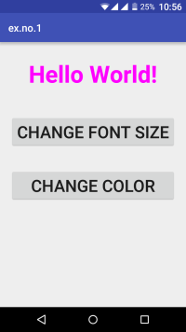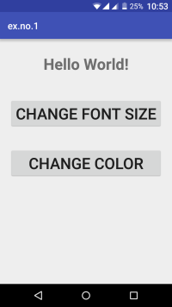Output:

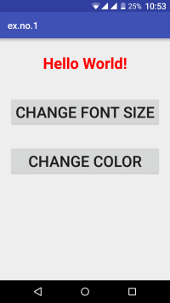

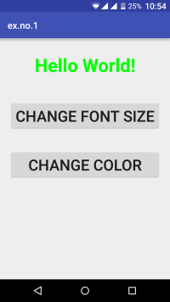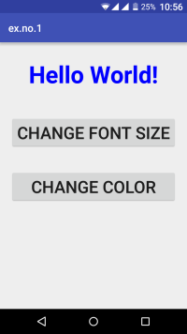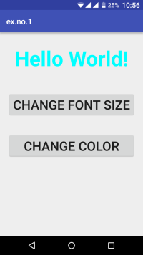

Result:

              Thus a Simple Android Application that uses GUI components, Font and Colors is developed and executed successfully.

**PROGRAM 2**

Aim:

       To develop a Simple Android Application that uses Layout Managers and Event Listeners.

**Procedure:**

**Creating a New project:**

* Open IDE and then click on **File -> New -> Android Application Project.**
* Then type the Application name as “**Program2″, Minimim Required SDK = API 14** and click **Next.**

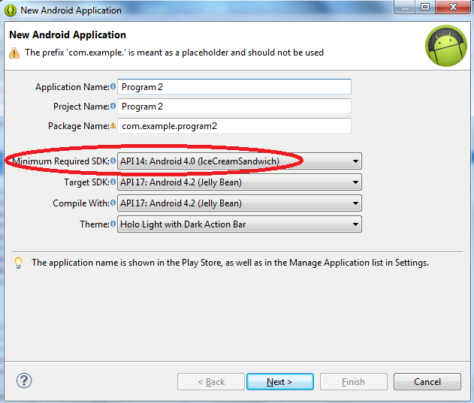

* Then click **Next.**
* Then click **Next.**
* Then select **Blank Activity** andclick **Next.**
* Finally click F**inish**.
* It will take some time to build and to load the project.
* After completion it will look as given below.

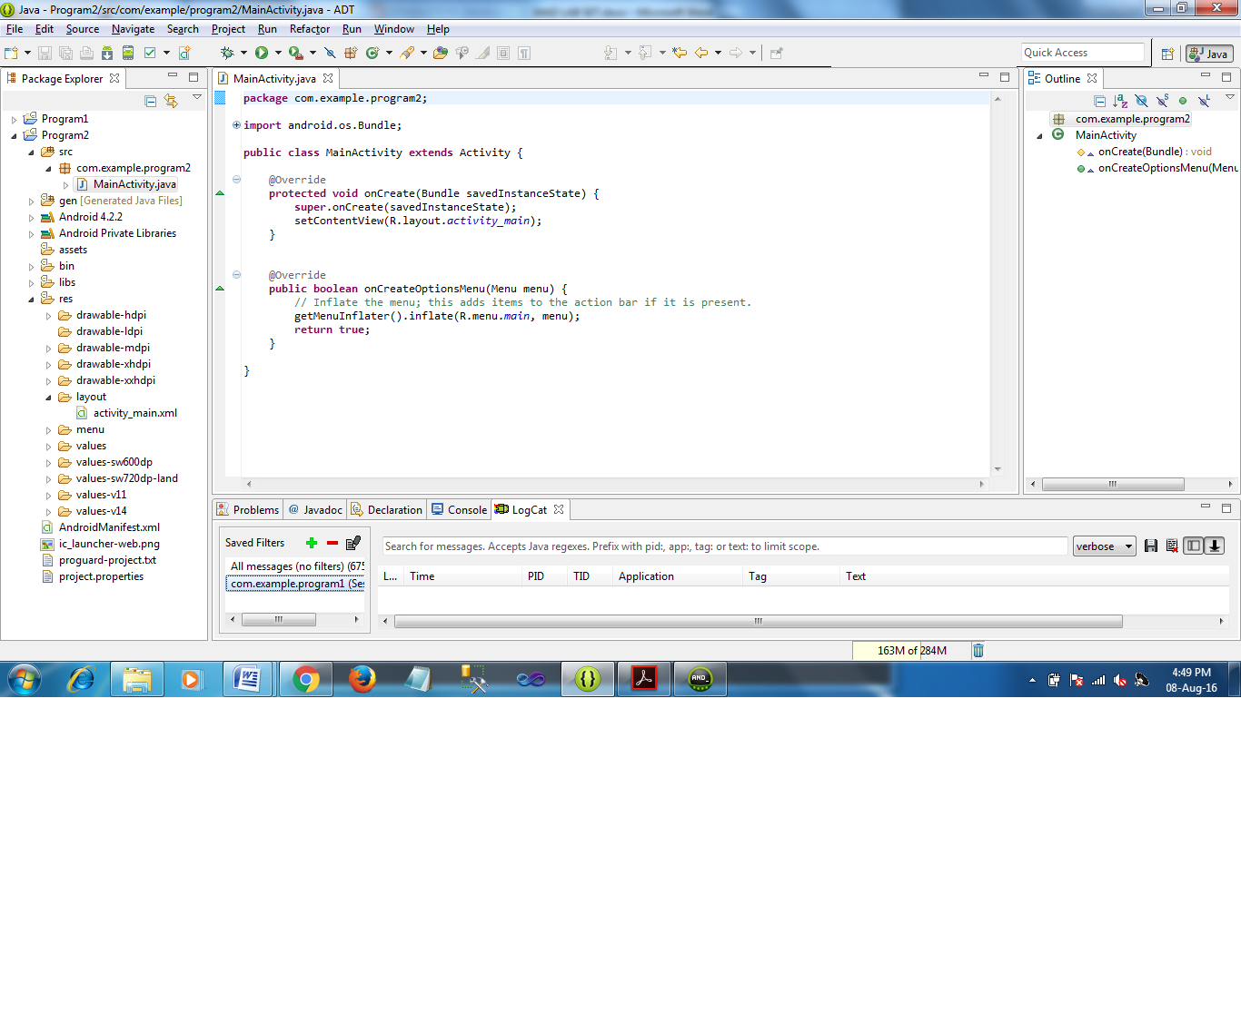

### Creating Second Activity for the Android Application:

### Click on Program2 -> New -> Other->Android->Android Activity.

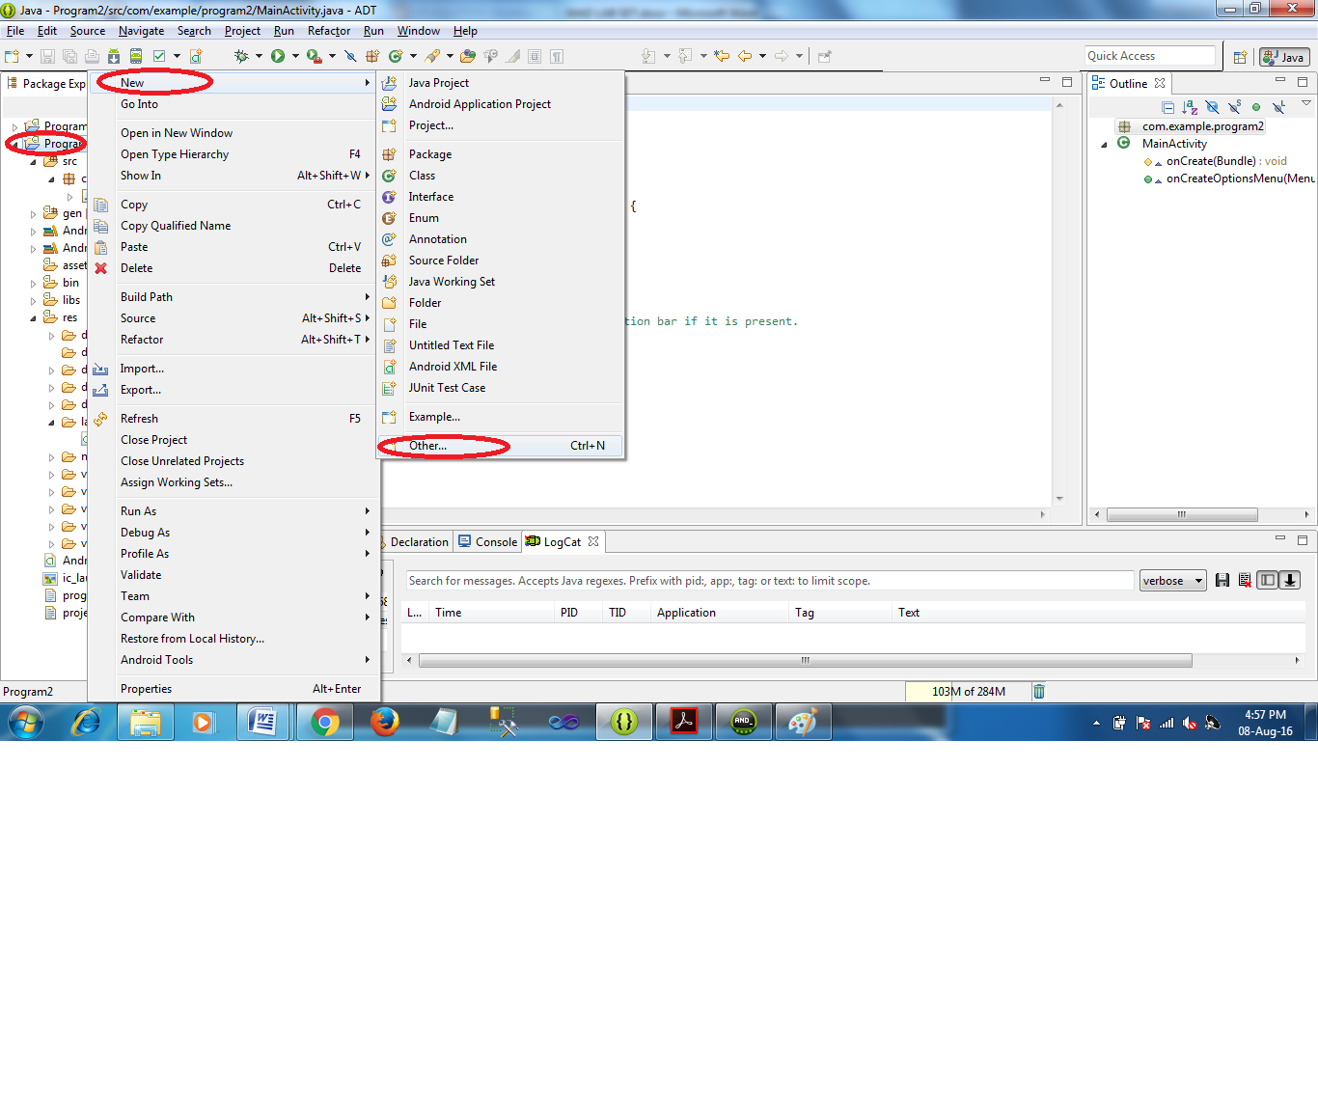

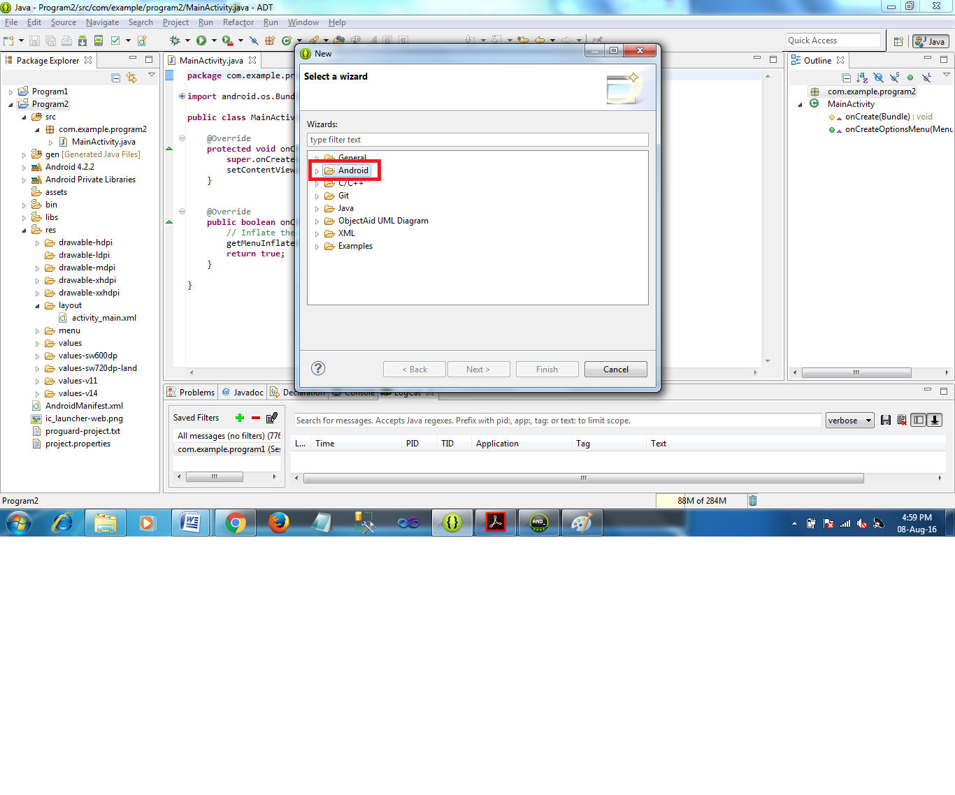

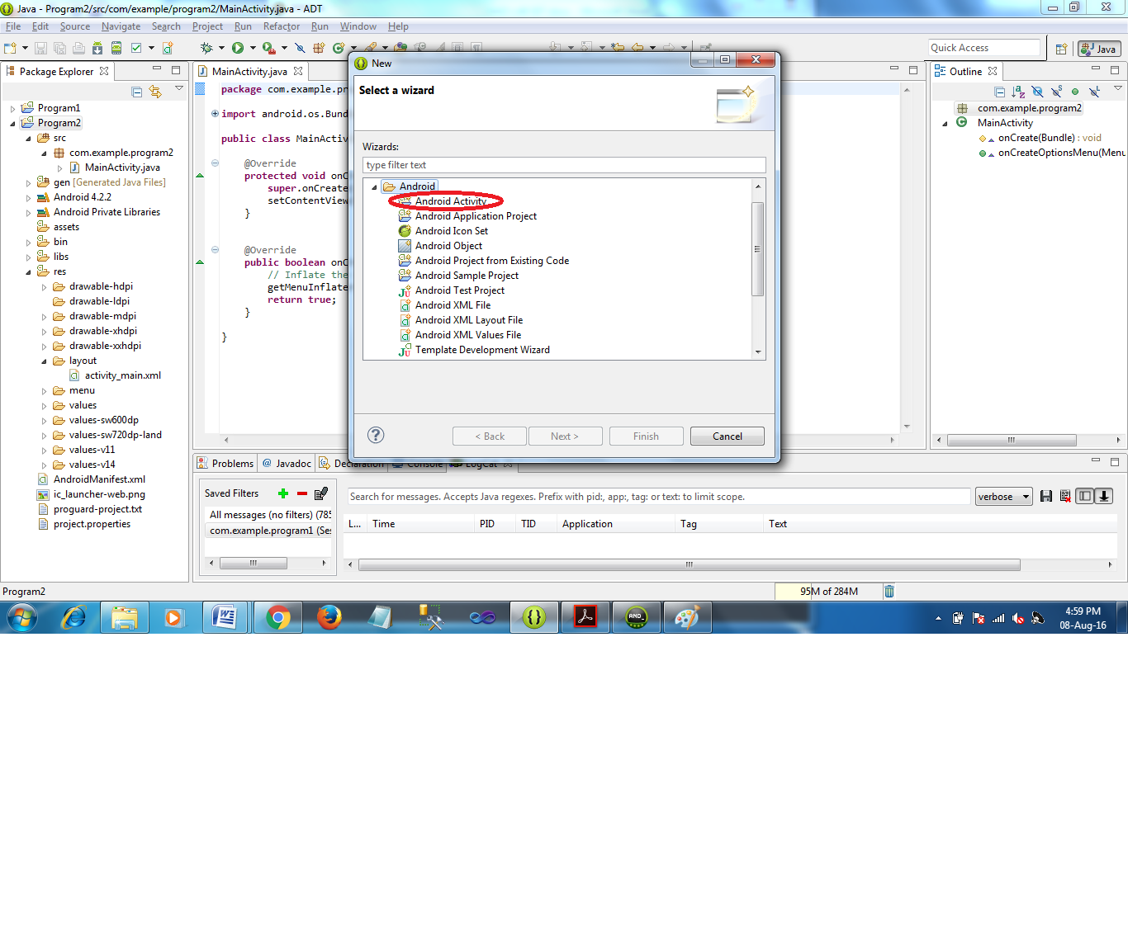

* **Then Specify the Activity Name as SecondActivity and click Finish button.**

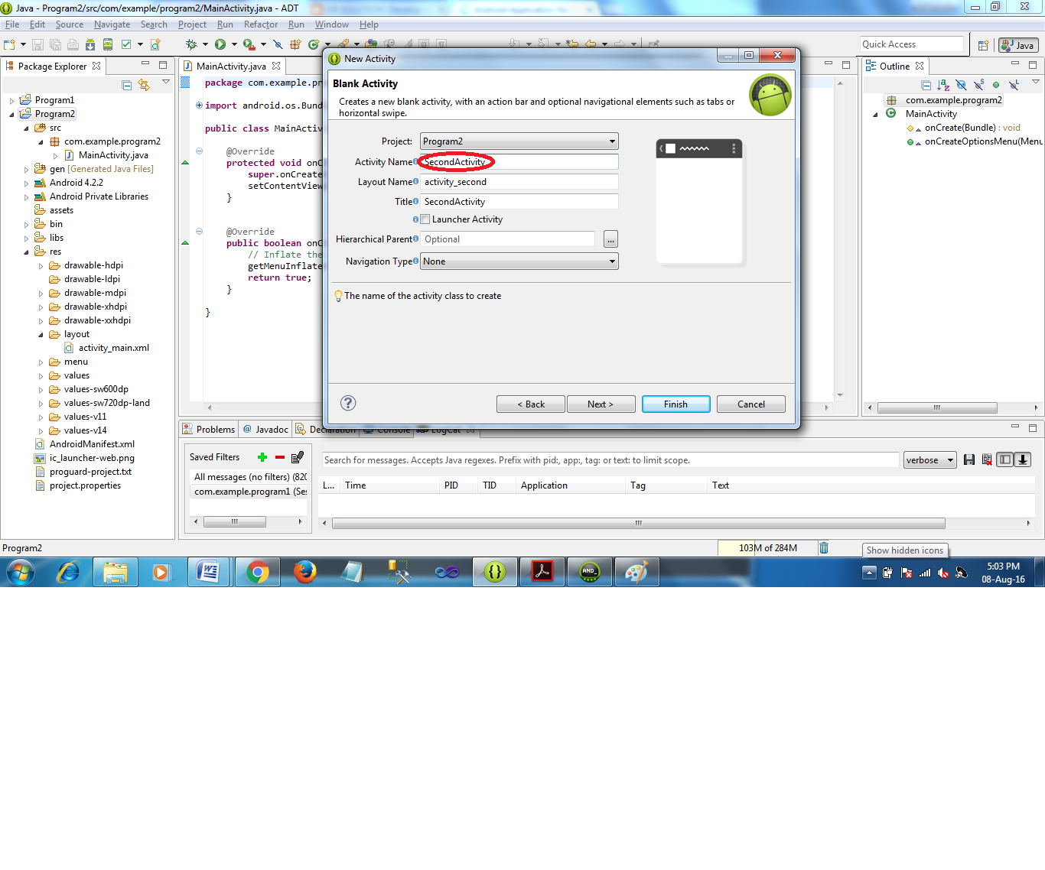

### Designing layout for the Android Application:

#### Designing Layout for Main Activity:

* Click on **Program2 -> res -> layout -> activity_main.xml.**
* Now go to XML code editor.
* Then delete the code which is there and type the code as given below.

**Code for Activity_main.xml:**

<?xml version=*"1.0"* encoding=*"utf-8"*?>

<RelativeLayout xmlns:android=*"http://schemas.android.com/apk/res/android"*

xmlns:tools=*"http://schemas.android.com/tools"*

android:layout_width=*"match_parent"*

android:layout_height=*"match_parent"*

tools:context=*".MainActivity"*>

<LinearLayout

android:layout_width=*"match_parent"*

android:layout_height=*"100dp"*>

<TextView

android:id=*"@+id/textView"*

android:layout_width=*"match_parent"*

android:layout_height=*"wrap_content"*

android:layout_margin=*"30dp"*

android:text=*"Details Form"*

android:textSize=*"25sp"*

android:gravity=*"center"*/>

</LinearLayout>

<GridLayout

android:id=*"@+id/gridLayout"*

android:layout_width=*"match_parent"*

android:layout_height=*"match_parent"*

android:layout_marginTop=*"100dp"*

android:layout_marginBottom=*"200dp"*

android:columnCount=*"2"*

android:rowCount=*"3"*>

<TextView

android:id=*"@+id/textView1"*

android:layout_width=*"wrap_content"*

android:layout_height=*"wrap_content"*

android:layout_margin=*"10dp"*

android:layout_row=*"0"*

android:layout_column=*"0"*

android:text=*"Name"*

android:textSize=*"20sp"*

android:gravity=*"center"*/>

<EditText

android:id=*"@+id/editText"*

android:layout_width=*"wrap_content"*

android:layout_height=*"wrap_content"*

android:layout_margin=*"10dp"*

android:layout_row=*"0"*

android:layout_column=*"1"*

android:ems=*"10"*/>

<TextView

android:id=*"@+id/textView2"*

android:layout_width=*"wrap_content"*

android:layout_height=*"wrap_content"*

android:layout_margin=*"10dp"*

android:layout_row=*"1"*

android:layout_column=*"0"*

android:text=*"Reg.No"*

android:textSize=*"20sp"*

android:gravity=*"center"*/>

<EditText

android:id=*"@+id/editText2"*

android:layout_width=*"wrap_content"*

android:layout_height=*"wrap_content"*

android:layout_margin=*"10dp"*

android:layout_row=*"1"*

android:layout_column=*"1"*

android:inputType=*"number"*

android:ems=*"10"*/>

<TextView

android:id=*"@+id/textView3"*

android:layout_width=*"wrap_content"*

android:layout_height=*"wrap_content"*

android:layout_margin=*"10dp"*

android:layout_row=*"2"*

android:layout_column=*"0"*

android:text=*"Dept"*

android:textSize=*"20sp"*

android:gravity=*"center"*/>

<Spinner

android:id=*"@+id/spinner"*

android:layout_width=*"wrap_content"*

android:layout_height=*"wrap_content"*

android:layout_margin=*"10dp"*

android:layout_row=*"2"*

android:layout_column=*"1"*

android:spinnerMode=*"dropdown"*/>

</GridLayout>

<Button

android:id=*"@+id/button"*

android:layout_width=*"wrap_content"*

android:layout_height=*"wrap_content"*

android:layout_alignParentBottom=*"true"*

android:layout_centerInParent=*"true"*

android:layout_marginBottom=*"150dp"*

android:text=*"Submit"*/>

</RelativeLayout>

* Now click on Design and your activity will look as given below.

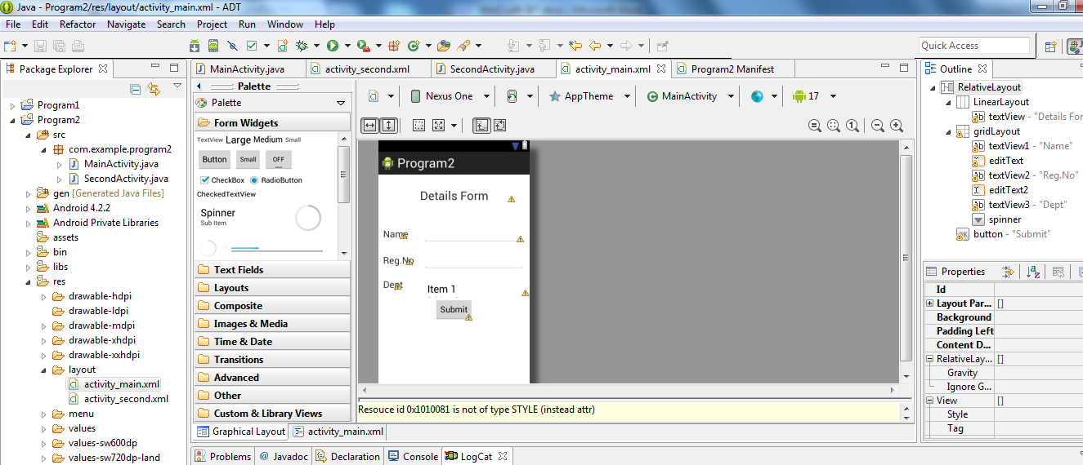

* So now the designing part of Main Activity is completed.

#### Designing Layout for Second Activity:

* Click on **app -> res -> layout -> activity_second.xml.**
* Now go to XML code editor.
* Then delete the code which is there and type the code as given below.

**Code for Activity_second.xml:**

<?xml version=*"1.0"* encoding=*"utf-8"*?>

<LinearLayout xmlns:android=*"http://schemas.android.com/apk/res/android"*

xmlns:tools=*"http://schemas.android.com/tools"*

android:layout_width=*"match_parent"*

android:layout_height=*"match_parent"*

tools:context=*"com.example.devang.exno2.SecondActivity"*

android:orientation=*"vertical"*

android:gravity=*"center"*>

<TextView

android:id=*"@+id/textView1"*

android:layout_width=*"wrap_content"*

android:layout_height=*"wrap_content"*

android:layout_margin=*"20dp"*

android:text=*"New Text"*

android:textSize=*"30sp"*/>

<TextView

android:id=*"@+id/textView2"*

android:layout_width=*"wrap_content"*

android:layout_height=*"wrap_content"*

android:layout_margin=*"20dp"*

android:text=*"New Text"*

android:textSize=*"30sp"*/>

<TextView

android:id=*"@+id/textView3"*

android:layout_width=*"wrap_content"*

android:layout_height=*"wrap_content"*

android:layout_margin=*"20dp"*

android:text=*"New Text"*

android:textSize=*"30sp"*/>

</LinearLayout>

* Now click on Design and your activity will look as given below.

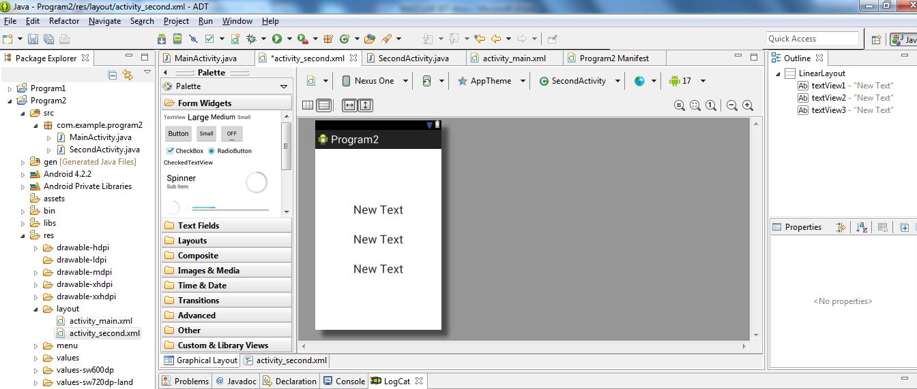

### Java Coding for the Android Application:

#### Java Coidng for Main Activity:

* Click on **Program2 -> src -> com.example.program2 -> MainActivity.**
* Then delete the code which is there and type the code as given below.

**Code for MainActivity.java:**

**package** com.example.program2;

**import** android.os.Bundle;

**import** android.app.Activity;

**import** android.content.Intent;

**import** android.view.View;

**import** android.widget.ArrayAdapter;

**import** android.widget.Button;

**import** android.widget.EditText;

**import** android.widget.Spinner;

**public** **class** MainActivity **extends** Activity {

//Defining the Views

EditText e1,e2;

Button bt;

Spinner s;

//Data for populating in Spinner

String [] dept_array={"ISE","ECE","CSE","Mech","Civil"};

String name,reg,dept;

@Override

**protected** **void** onCreate(Bundle savedInstanceState) {

**super**.onCreate(savedInstanceState);

setContentView(R.layout.*activity_main*);

//Referring the Views

e1= (EditText) findViewById(R.id.*editText*);

e2= (EditText) findViewById(R.id.*editText2*);

bt= (Button) findViewById(R.id.*button*);

s= (Spinner) findViewById(R.id.*spinner*);

//Creating Adapter for Spinner for adapting the data from array to Spinner

ArrayAdapter adapter= **new** ArrayAdapter(MainActivity.**this**,android.R.layout.*simple_spinner_item*,dept_array);

s.setAdapter(adapter);

//Creating Listener for Button

bt.setOnClickListener(**new** View.OnClickListener() {

@Override

**public** **void** onClick(View v) {

//Getting the Values from Views(Edittext & Spinner)

name=e1.getText().toString();

reg=e2.getText().toString();

dept=s.getSelectedItem().toString();

//Intent For Navigating to Second Activity

Intent i = **new** Intent(MainActivity.**this**,SecondActivity.**class**);

//For Passing the Values to Second Activity

i.putExtra("name_key", name);

i.putExtra("reg_key",reg);

i.putExtra("dept_key", dept);

startActivity(i);

}

});

}

}

* So now the Coding part of Main Activity is completed.

#### Java Coding for Second Activity:

* Click on **Program2 -> src -> com.example.program2 -> SecondActivity.**
* Then delete the code which is there and type the code as given below.

**Code for SecondActivity.java:**

**package** com.example.program2;

**import** android.os.Bundle;

**import** android.app.Activity;

**import** android.content.Intent;

**import** android.widget.TextView;

**public** **class** SecondActivity **extends** Activity {

TextView t1,t2,t3;

String name,reg,dept;

@Override

**protected** **void** onCreate(Bundle savedInstanceState) {

**super**.onCreate(savedInstanceState);

setContentView(R.layout.*activity_second*);

t1= (TextView) findViewById(R.id.*textView1*);

t2= (TextView) findViewById(R.id.*textView2*);

t3= (TextView) findViewById(R.id.*textView3*);

//Getting the Intent

Intent i = getIntent();

//Getting the Values from First Activity using the Intent received

name=i.getStringExtra("name_key");

reg=i.getStringExtra("reg_key");

dept=i.getStringExtra("dept_key");

//Setting the Values to Intent

t1.setText(name);

t2.setText(reg);

t3.setText(dept);

}

}

* So now the Coding part of Second Activity is also completed.
* Now run the application to see the output.

Output:

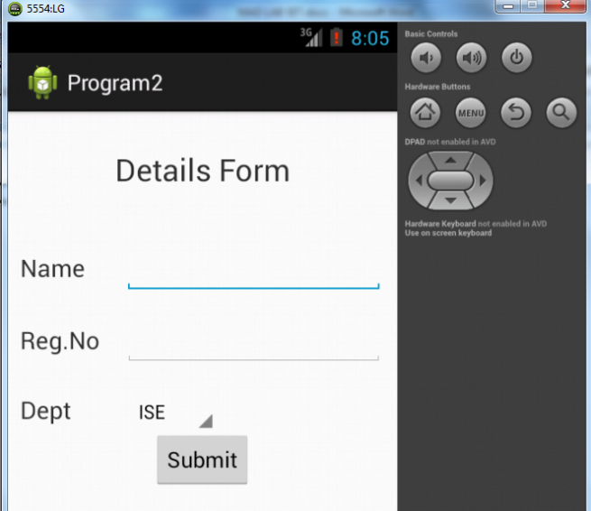

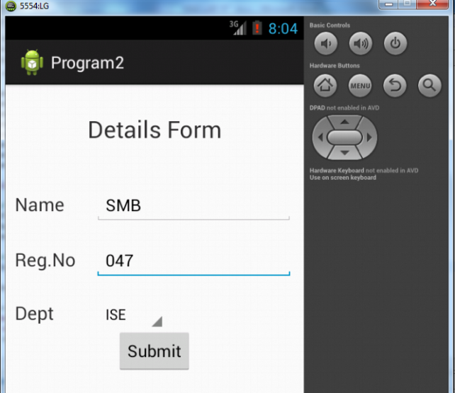

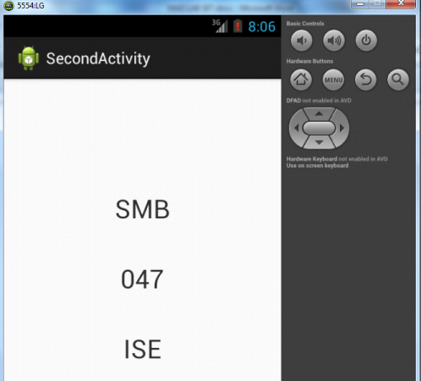

## Result:

              Thus a Simple Android Application that uses Layout Managers and Event Listeners is developed and executed successfully.

**PROGRAM 3**

Aim:

       To develop a Simple Android Application for Native Calculator.

Procedure:

### Designing layout for the Android Application:

#### Designing Layout for Main Activity:

* Click on **Program3 -> res -> layout -> activity_main.xml.**
* Now go to XML code editor.
* Then delete the code which is there and type the code as given below.

**Code for Activity_main.xml:**

<?xml version=*"1.0"* encoding=*"utf-8"*?>

<LinearLayout

xmlns:android=*"http://schemas.android.com/apk/res/android"*

android:orientation=*"vertical"*

android:layout_width=*"match_parent"*

android:layout_height=*"match_parent"*

android:layout_margin=*"20dp"*>

<LinearLayout

android:id=*"@+id/linearLayout1"*

android:layout_width=*"match_parent"*

android:layout_height=*"wrap_content"*

android:layout_margin=*"20dp"*>

<EditText

android:id=*"@+id/editText1"*

android:layout_width=*"match_parent"*

android:layout_height=*"wrap_content"*

android:layout_weight=*"1"*

android:inputType=*"numberDecimal"*

android:textSize=*"20sp"* />

<EditText

android:id=*"@+id/editText2"*

android:layout_width=*"match_parent"*

android:layout_height=*"wrap_content"*

android:layout_weight=*"1"*

android:inputType=*"numberDecimal"*

android:textSize=*"20sp"* />

</LinearLayout>

<LinearLayout

android:id=*"@+id/linearLayout2"*

android:layout_width=*"match_parent"*

android:layout_height=*"wrap_content"*

android:layout_margin=*"20dp"*>

<Button

android:id=*"@+id/Add"*

android:layout_width=*"match_parent"*

android:layout_height=*"wrap_content"*

android:layout_weight=*"1"*

android:text=*"+"*

android:textSize=*"30sp"*/>

<Button

android:id=*"@+id/Sub"*

android:layout_width=*"match_parent"*

android:layout_height=*"wrap_content"*

android:layout_weight=*"1"*

android:text=*"-"*

android:textSize=*"30sp"*/>

<Button

android:id=*"@+id/Mul"*

android:layout_width=*"match_parent"*

android:layout_height=*"wrap_content"*

android:layout_weight=*"1"*

android:text=*"*"*

android:textSize=*"30sp"*/>

<Button

android:id=*"@+id/Div"*

android:layout_width=*"match_parent"*

android:layout_height=*"wrap_content"*

android:layout_weight=*"1"*

android:text=*"/"*

android:textSize=*"30sp"*/>

</LinearLayout>

<TextView

android:id=*"@+id/textView"*

android:layout_width=*"match_parent"*

android:layout_height=*"wrap_content"*

android:layout_marginTop=*"50dp"*

android:text=*"Answer is"*

android:textSize=*"30sp"*

android:gravity=*"center"*/>

</LinearLayout>

* Now click on Design and your activity will look as given below.

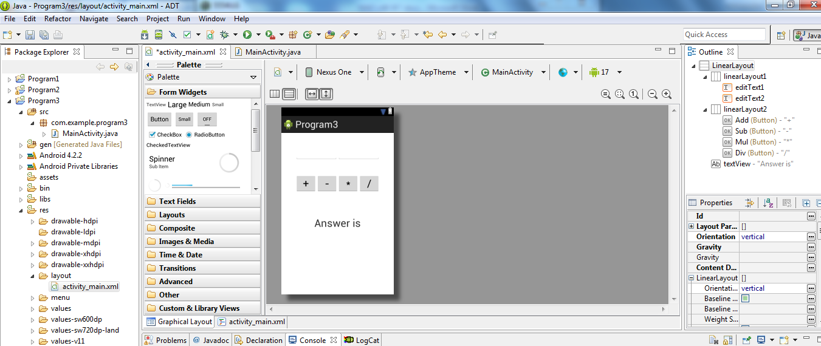

* So now the designing part is completed.

Java Coding for the Android Application:

* Click on **Program3 ->src -> com.example.Program3 -> MainActivity.**

**package** com.example.program3;

**import** android.os.Bundle;

**import** android.app.Activity;

**import** android.text.TextUtils;

**import** android.view.View;

**import** android.view.View.OnClickListener;

**import** android.widget.Button;

**import** android.widget.EditText;

**import** android.widget.TextView;

**public** **class** MainActivity **extends** Activity **implements** OnClickListener{

//Defining the Views

EditText Num1;

EditText Num2;

Button Add;

Button Sub;

Button Mul;

Button Div;

TextView Result;

@Override

**public** **void** onCreate(Bundle savedInstanceState)

{

**super**.onCreate(savedInstanceState);

setContentView(R.layout.*activity_main*);

//Referring the Views

Num1 = (EditText) findViewById(R.id.*editText1*);

Num2 = (EditText) findViewById(R.id.*editText2*);

Add = (Button) findViewById(R.id.*Add*);

Sub = (Button) findViewById(R.id.*Sub*);

Mul = (Button) findViewById(R.id.*Mul*);

Div = (Button) findViewById(R.id.*Div*);

Result = (TextView) findViewById(R.id.*textView*);

// set a listener

Add.setOnClickListener(**this**);

Sub.setOnClickListener(**this**);

Mul.setOnClickListener(**this**);

Div.setOnClickListener(**this**);

}

@Override

**public** **void** onClick (View v)

{

**float** num1 = 0;

**float** num2 = 0;

**float** result = 0;

String oper = "";

// check if the fields are empty

**if** (TextUtils.*isEmpty*(Num1.getText().toString()) || TextUtils.*isEmpty*(Num2.getText().toString()))

**return**;

// read EditText and fill variables with numbers

num1 = Float.*parseFloat*(Num1.getText().toString());

num2 = Float.*parseFloat*(Num2.getText().toString());

// defines the button that has been clicked and performs the corresponding operation

// write operation into oper, we will use it later for output

**switch** (v.getId())

{

**case** R.id.*Add*:

oper = "+";

result = num1 + num2;

**break**;

**case** R.id.*Sub*:

oper = "-";

result = num1 - num2;

**break**;

**case** R.id.*Mul*:

oper = "*";

result = num1 * num2;

**break**;

**case** R.id.*Div*:

oper = "/";

result = num1 / num2;

**break**;

**default**:

**break**;

}

// form the output line

Result.setText(num1 + " " + oper + " " + num2 + " = " + result);

}

}

* So now the Coding part is also completed.
* Now run the application to see the output.

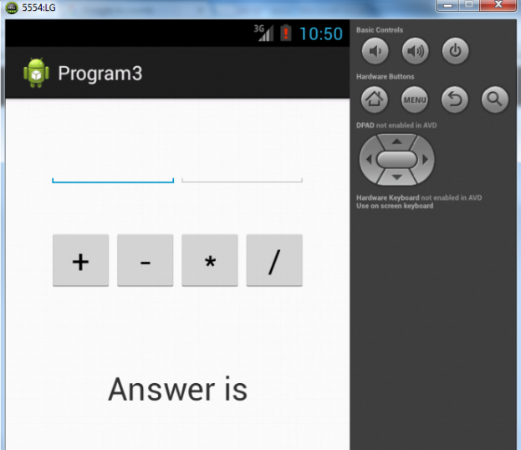

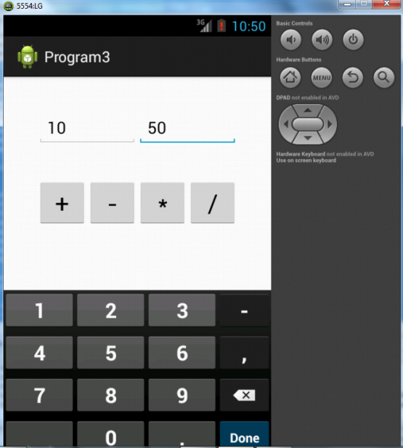

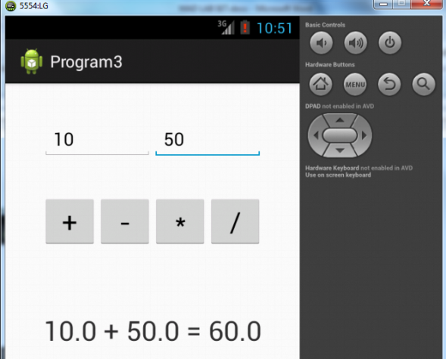

Result:

              Thus a Simple Android Application for Native Calculator is developed and executed successfully.

**PROGRAM 4**

Aim:

To develop a Simple Android Application that draws basic Graphical Primitives on the screen.

Procedure:

### Designing layout for the Android Application:

#### Designing Layout for Main Activity:

* Click on **Program4 -> res -> layout -> activity_main.xml.**
* Now go to XML code editor.
* Then delete the code which is there and type the code as given below.

**Code for Activity_main.xml:**

<?xml version=*"1.0"* encoding=*"utf-8"*?>

<RelativeLayout xmlns:android=*"http://schemas.android.com/apk/res/android"*

android:layout_width=*"match_parent"*

android:layout_height=*"match_parent"*>

<ImageView

android:layout_width=*"match_parent"*

android:layout_height=*"match_parent"*

android:id=*"@+id/imageView"* />

</RelativeLayout>

* Now click on Design and your activity will look as given below.

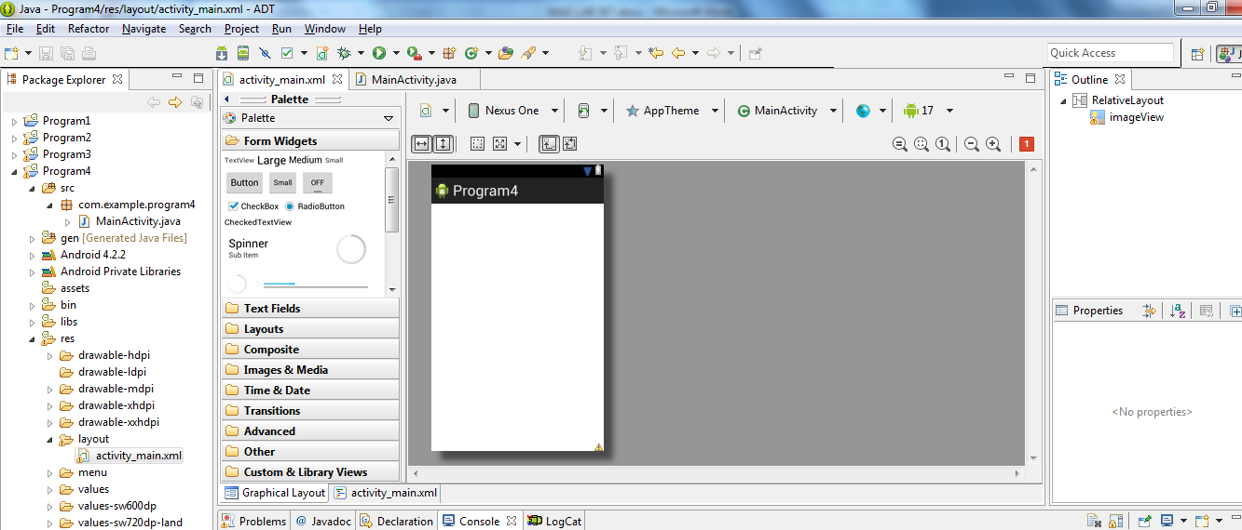

* So now the designing part is completed.

Java Coding for the Android Application:

Click on **Program4 ->src -> com.example.Program4 -> MainActivity.**

**package** com.example.program4;

**import** android.os.Bundle;

**import** android.app.Activity;

**import** android.graphics.Bitmap;

**import** android.graphics.Canvas;

**import** android.graphics.Color;

**import** android.graphics.Paint;

**import** android.graphics.drawable.BitmapDrawable;

**import** android.widget.ImageView;

**public** **class** MainActivity **extends** Activity {

@Override

**public** **void** onCreate(Bundle savedInstanceState)

{

**super**.onCreate(savedInstanceState);

setContentView(R.layout.*activity_main*);

//Creating a Bitmap

Bitmap bg = Bitmap.*createBitmap*(720, 1280, Bitmap.Config.*ARGB_8888*);

//Setting the Bitmap as background for the ImageView

ImageView i = (ImageView) findViewById(R.id.*imageView*);

i.setBackgroundDrawable(**new** BitmapDrawable(bg));

//Creating the Canvas Object

Canvas canvas = **new** Canvas(bg);

//Creating the Paint Object and set its color & TextSize

Paint paint = **new** Paint();

paint.setColor(Color.*BLUE*);

paint.setTextSize(50);

//To draw a Rectangle

canvas.drawText("Rectangle", 420, 150, paint);

canvas.drawRect(400, 200, 650, 700, paint);

//To draw a Circle

canvas.drawText("Circle", 120, 150, paint);

canvas.drawCircle(200, 350, 150, paint);

//To draw a Square

canvas.drawText("Square", 120, 800, paint);

canvas.drawRect(50, 850, 350, 1150, paint);

//To draw a Line

canvas.drawText("Line", 480, 800, paint);

canvas.drawLine(520, 850, 520, 1150, paint);

}

}

* So now the Coding part is also completed.
* Now run the application to see the output.

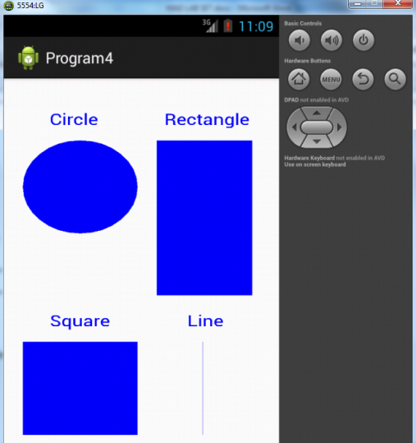

Result:

              Thus a Simple Android Application that draws basic Graphical Primitives on the screen is developed and executed successfully.

**PROGRAM 5**

Aim:

To develop a Simple Android Application that makes use of Database.

Procedure:

### Designing layout for the Android Application:

#### Designing Layout for Main Activity:

* Click on **Program5 -> res -> layout -> activity_main.xml.**
* Now go to XML code editor.
* Then delete the code which is there and type the code as given below.

**Code for Activity_main.xml:**

<?xml version=*"1.0"* encoding=*"utf-8"*?>

<AbsoluteLayout xmlns:android=*"http://schemas.android.com/apk/res/android"*

android:layout_width=*"match_parent"*

android:layout_height=*"match_parent"*>

<TextView

android:layout_width=*"wrap_content"*

android:layout_height=*"wrap_content"*

android:layout_x=*"50dp"*

android:layout_y=*"20dp"*

android:text=*"Student Details"*

android:textSize=*"30sp"* />

<TextView

android:layout_width=*"wrap_content"*

android:layout_height=*"wrap_content"*

android:layout_x=*"20dp"*

android:layout_y=*"82dp"*

android:text=*"Enter Rollno:"*

android:textSize=*"20sp"* />

<TextView

android:layout_width=*"wrap_content"*

android:layout_height=*"wrap_content"*

android:layout_x=*"24dp"*

android:layout_y=*"131dp"*

android:text=*"Enter Name:"*

android:textSize=*"20sp"* />

<TextView

android:layout_width=*"wrap_content"*

android:layout_height=*"wrap_content"*

android:layout_x=*"26dp"*

android:layout_y=*"181dp"*

android:text=*"Enter Marks:"*

android:textSize=*"20sp"* />

<EditText

android:id=*"@+id/Name"*

android:layout_width=*"150dp"*

android:layout_height=*"wrap_content"*

android:layout_x=*"152dp"*

android:layout_y=*"126dp"*

android:ems=*"10"*

android:inputType=*"text"*

android:textSize=*"20sp"* />

<EditText

android:id=*"@+id/Marks"*

android:layout_width=*"150dp"*

android:layout_height=*"wrap_content"*

android:layout_x=*"155dp"*

android:layout_y=*"172dp"*

android:ems=*"10"*

android:inputType=*"number"*

android:textSize=*"20sp"* />

<EditText

android:id=*"@+id/Rollno"*

android:layout_width=*"150dp"*

android:layout_height=*"wrap_content"*

android:layout_x=*"152dp"*

android:layout_y=*"77dp"*

android:ems=*"10"*

android:inputType=*"number"*

android:textSize=*"20sp"* >

<requestFocus />

</EditText>

<Button

android:id=*"@+id/Insert"*

android:layout_width=*"150dp"*

android:layout_height=*"wrap_content"*

android:layout_x=*"10dp"*

android:layout_y=*"256dp"*

android:text=*"Insert"*

android:textSize=*"30dp"* />

<Button

android:id=*"@+id/Delete"*

android:layout_width=*"150dp"*

android:layout_height=*"wrap_content"*

android:layout_x=*"173dp"*

android:layout_y=*"257dp"*

android:text=*"Delete"*

android:textSize=*"30dp"* />

<Button

android:id=*"@+id/Update"*

android:layout_width=*"138dp"*

android:layout_height=*"wrap_content"*

android:layout_x=*"15dp"*

android:layout_y=*"335dp"*

android:text=*"Update"*

android:textSize=*"30dp"* />

<Button

android:id=*"@+id/View"*

android:layout_width=*"150dp"*

android:layout_height=*"wrap_content"*

android:layout_x=*"171dp"*

android:layout_y=*"338dp"*

android:text=*"View"*

android:textSize=*"30dp"* />

<Button

android:id=*"@+id/ViewAll"*

android:layout_width=*"200dp"*

android:layout_height=*"wrap_content"*

android:layout_x=*"65dp"*

android:layout_y=*"401dp"*

android:text=*"View All"*

android:textSize=*"30dp"* />

</AbsoluteLayout>

* Now click on Design and your activity will look as given below.

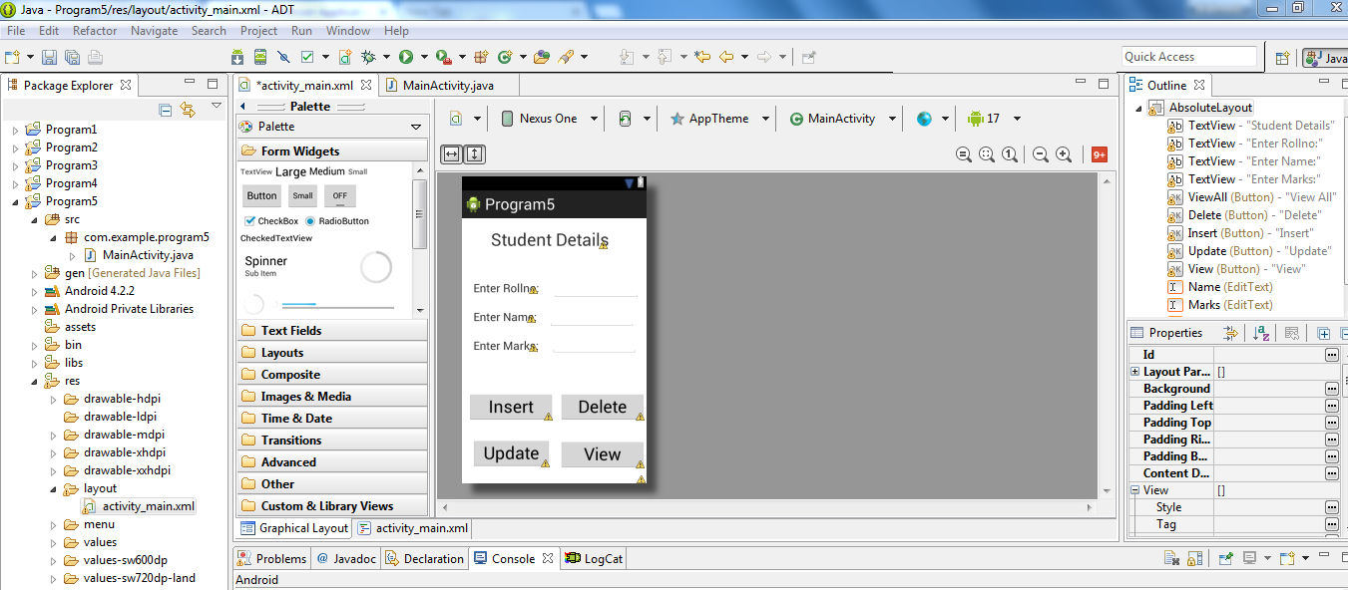

* So now the designing part is completed.

Java Coding for the Android Application:

Click on **Program5 ->src -> com.example.Program5 -> MainActivity.**

**package** com.example.program5;

**import** android.os.Bundle;

**import** android.app.Activity;

**import** android.content.Context;

**import** android.app.AlertDialog.Builder;

**import** android.database.Cursor;

**import** android.database.sqlite.SQLiteDatabase;

**import** android.view.View.OnClickListener;

**import** android.widget.Button;

**import** android.widget.EditText;

**public** **class** MainActivity **extends** Activity **implements** OnClickListener {

EditText Rollno,Name,Marks;

Button Insert,Delete,Update,View,ViewAll;

SQLiteDatabase db;

/** Called when the activity is first created. */

@Override

**public** **void** onCreate(Bundle savedInstanceState)

{

**super**.onCreate(savedInstanceState);

setContentView(R.layout.*activity_main*);

Rollno=(EditText)findViewById(R.id.*Rollno*);

Name=(EditText)findViewById(R.id.*Name*);

Marks=(EditText)findViewById(R.id.*Marks*);

Insert=(Button)findViewById(R.id.*Insert*);

Delete=(Button)findViewById(R.id.*Delete*);

Update=(Button)findViewById(R.id.*Update*);

View=(Button)findViewById(R.id.*View*);

ViewAll=(Button)findViewById(R.id.*ViewAll*);

Insert.setOnClickListener(**this**);

Delete.setOnClickListener(**this**);

Update.setOnClickListener(**this**);

View.setOnClickListener(**this**);

ViewAll.setOnClickListener(**this**);

// Creating database and table

db=openOrCreateDatabase("StudentDB", Context.*MODE_PRIVATE*, **null**);

db.execSQL("CREATE TABLE IF NOT EXISTS student(rollno VARCHAR,name VARCHAR,marks VARCHAR);");

}

**public** **void** onClick(android.view.View view)

{

// Inserting a record to the Student table

**if**(view==Insert)

{

// Checking for empty fields

**if**(Rollno.getText().toString().trim().length()==0||

Name.getText().toString().trim().length()==0||

Marks.getText().toString().trim().length()==0)

{

showMessage("Error", "Please enter all values");

**return**;

}

db.execSQL("INSERT INTO student VALUES('"+Rollno.getText()+"','"+Name.getText()+

"','"+Marks.getText()+"');");

showMessage("Success", "Record added");

clearText();

}

// Deleting a record from the Student table

**if**(view==Delete)

{

// Checking for empty roll number

**if**(Rollno.getText().toString().trim().length()==0)

{

showMessage("Error", "Please enter Rollno");

**return**;

}

Cursor c=db.rawQuery("SELECT * FROM student WHERE rollno='"+Rollno.getText()+"'", **null**);

**if**(c.moveToFirst())

{

db.execSQL("DELETE FROM student WHERE rollno='"+Rollno.getText()+"'");

showMessage("Success", "Record Deleted");

}

**else**

{

showMessage("Error", "Invalid Rollno");

}

clearText();

}

// Updating a record in the Student table

**if**(view==Update)

{

// Checking for empty roll number

**if**(Rollno.getText().toString().trim().length()==0)

{

showMessage("Error", "Please enter Rollno");

**return**;

}

Cursor c=db.rawQuery("SELECT * FROM student WHERE rollno='"+Rollno.getText()+"'", **null**);

**if**(c.moveToFirst()) {

db.execSQL("UPDATE student SET name='" + Name.getText() + "',marks='" + Marks.getText() +

"' WHERE rollno='"+Rollno.getText()+"'");

showMessage("Success", "Record Modified");

}

**else** {

showMessage("Error", "Invalid Rollno");

}

clearText();

}

// Display a record from the Student table

**if**(view==View)

{

// Checking for empty roll number

**if**(Rollno.getText().toString().trim().length()==0)

{

showMessage("Error", "Please enter Rollno");

**return**;

}

Cursor c=db.rawQuery("SELECT * FROM student WHERE rollno='"+Rollno.getText()+"'", **null**);

**if**(c.moveToFirst())

{

Name.setText(c.getString(1));

Marks.setText(c.getString(2));

}

**else**

{

showMessage("Error", "Invalid Rollno");

clearText();

}

}

// Displaying all the records

**if**(view==ViewAll)

{

Cursor c=db.rawQuery("SELECT * FROM student", **null**);

**if**(c.getCount()==0)

{

showMessage("Error", "No records found");

**return**;

}

StringBuffer buffer=**new** StringBuffer();

**while**(c.moveToNext())

{

buffer.append("Rollno: "+c.getString(0)+"\n");

buffer.append("Name: "+c.getString(1)+"\n");

buffer.append("Marks: "+c.getString(2)+"\n\n");

}

showMessage("Student Details", buffer.toString());

}

}

**public** **void** showMessage(String title,String message)

{

Builder builder=**new** Builder(**this**);

builder.setCancelable(**true**);

builder.setTitle(title);

builder.setMessage(message);

builder.show();

}

**public** **void** clearText()

{

Rollno.setText("");

Name.setText("");

Marks.setText("");

Rollno.requestFocus();

}

}

* So now the Coding part is also completed.
* Now run the application to see the output.

Output:

Getting Exception Check

**PROGRAM 10**

Aim:

To develop an application that creates an alert upon receiving a message.

Procedure:

Create Main Activity for the Android Application

**Minimim Required SDK = API 16** and click **Next.**

Create Second Activity for the Android Application

### Designing layout for the Android Application:

#### Designing Layout for Main Activity:

* Click on **Program10 -> res -> layout -> activity_main.xml.**
* Now go to XML code editor.
* Then delete the code which is there and type the code as given below.

**Code for Activity_main.xml:**

<?xml version=*"1.0"* encoding=*"utf-8"*?>

<LinearLayout xmlns:android=*"http://schemas.android.com/apk/res/android"*

android:layout_width=*"match_parent"*

android:layout_height=*"match_parent"*

android:layout_margin=*"10dp"*

android:orientation=*"vertical"*>

<TextView

android:layout_width=*"wrap_content"*

android:layout_height=*"wrap_content"*

android:text=*"Message"*

android:textSize=*"30sp"* />

<EditText

android:id=*"@+id/editText"*

android:layout_width=*"match_parent"*

android:layout_height=*"wrap_content"*

android:singleLine=*"true"*

android:textSize=*"30sp"* />

<Button

android:id=*"@+id/button"*

android:layout_width=*"wrap_content"*

android:layout_height=*"wrap_content"*

android:layout_margin=*"30dp"*

android:layout_gravity=*"center"*

android:text=*"Notify"*

android:textSize=*"30sp"*/>

</LinearLayout>

* Now click on Design and your activity will look as given below.

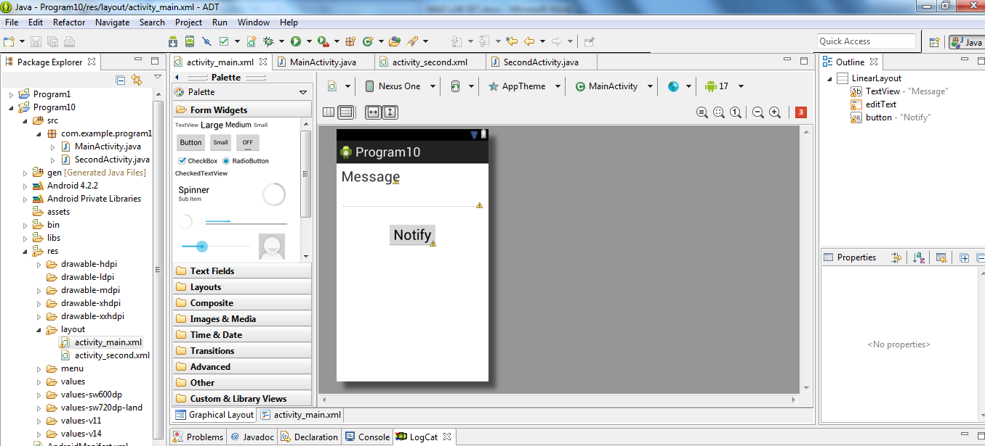

* So now the designing part is completed.

Java Coding for the Android Application:

Click on **Program10 ->src -> com.example.Program10 -> MainActivity.**

**package** com.example.program10;

**import** android.os.Bundle;

**import** android.app.Activity;

**import** android.app.Notification;

**import** android.app.NotificationManager;

**import** android.app.PendingIntent;

**import** android.content.Intent;

**import** android.view.Menu;

**import** android.view.View;

**import** android.view.View.OnClickListener;

**import** android.widget.Button;

**import** android.widget.EditText;

**public** **class** MainActivity **extends** Activity **implements** OnClickListener{

Button notify;

EditText e;

@Override

**protected** **void** onCreate(Bundle savedInstanceState)

{

**super**.onCreate(savedInstanceState);

setContentView(R.layout.*activity_main*);

notify= (Button) findViewById(R.id.*button*);

e= (EditText) findViewById(R.id.*editText*);

notify.setOnClickListener(**new** View.OnClickListener()

{

@Override

**public** **void** onClick(View v)

{

Intent intent = **new** Intent(MainActivity.**this**, SecondActivity.**class**);

PendingIntent pending = PendingIntent.*getActivity*(MainActivity.**this**, 0, intent, 0);

Notification noti = **new** Notification.Builder(MainActivity.**this**).setContentTitle("New Message").setContentText(e.getText().toString()).setSmallIcon(R.drawable.*ic_launcher*).setContentIntent(pending).build();

NotificationManager manager = (NotificationManager) getSystemService(*NOTIFICATION_SERVICE*);

noti.flags |= Notification.*FLAG_AUTO_CANCEL*;

manager.notify(0, noti);

}

});

}

@Override

**public** **void** onClick(View arg0) {

// **TODO** Auto-generated method stub

}

}

* So now the Coding part is also completed.
* Now run the application to see the output.

Output:

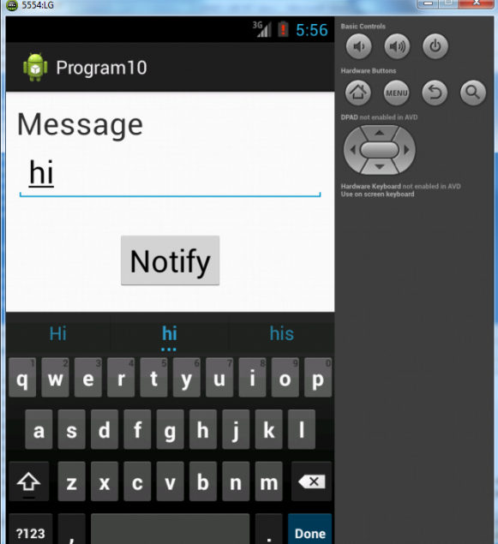

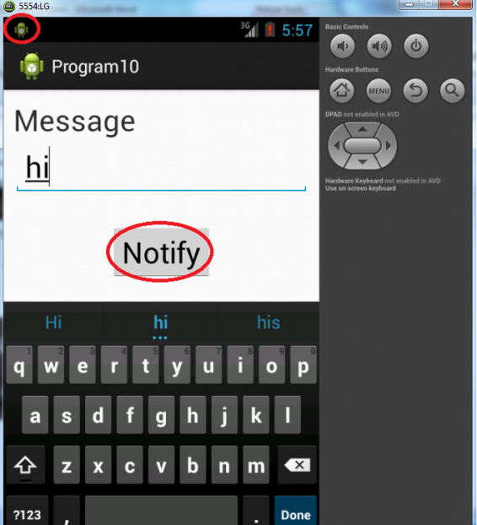

Result:

              Thus Android Application that creates an alert upon receiving a message is developed and executed successfully.

**PROGRAM 11**

Aim:

To develop a mobile application that creates alarm clock.

Procedure:

Create Main Activity for the Android Application

**Minimim Required SDK = API 16** and click **Next.**

Create Second Activity for the Android Application

### Designing layout for the Android Application:

#### Designing Layout for Main Activity:

* Click on **Program11 -> res -> layout -> activity_main.xml.**
* Now go to XML code editor.
* Then delete the code which is there and type the code as given below.

**Code for Activity_main.xml:**

<?xml version=*"1.0"* encoding=*"utf-8"*?>

<LinearLayout xmlns:android=*"http://schemas.android.com/apk/res/android"*

android:layout_width=*"match_parent"*

android:layout_height=*"match_parent"*

android:orientation=*"vertical"*>

<TimePicker

android:id=*"@+id/timePicker"*

android:layout_width=*"wrap_content"*

android:layout_height=*"wrap_content"*

android:layout_gravity=*"center"* />

<ToggleButton

android:id=*"@+id/toggleButton"*

android:layout_width=*"wrap_content"*

android:layout_height=*"wrap_content"*

android:layout_gravity=*"center"*

android:layout_margin=*"20dp"*

android:checked=*"false"*

android:onClick=*"OnToggleClicked"* />

</LinearLayout>

* Now click on **Design** and your application will look as given below.

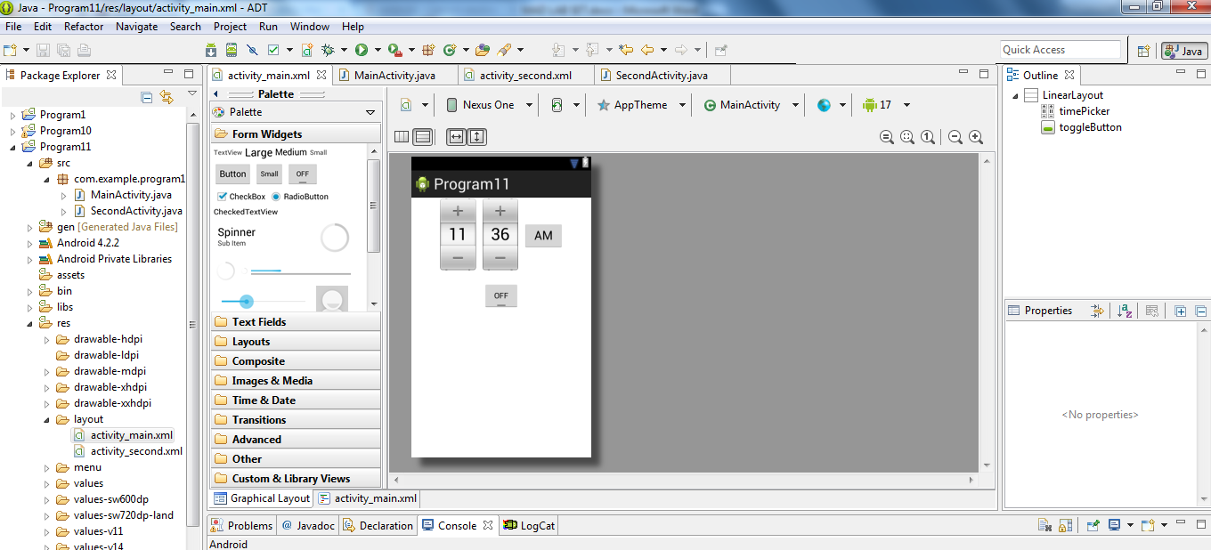

* So now the designing part is completed.

Changes in Manifest for the Android Application:

* Click on **Program11 -> manifests -> AndroidManifest.xml**

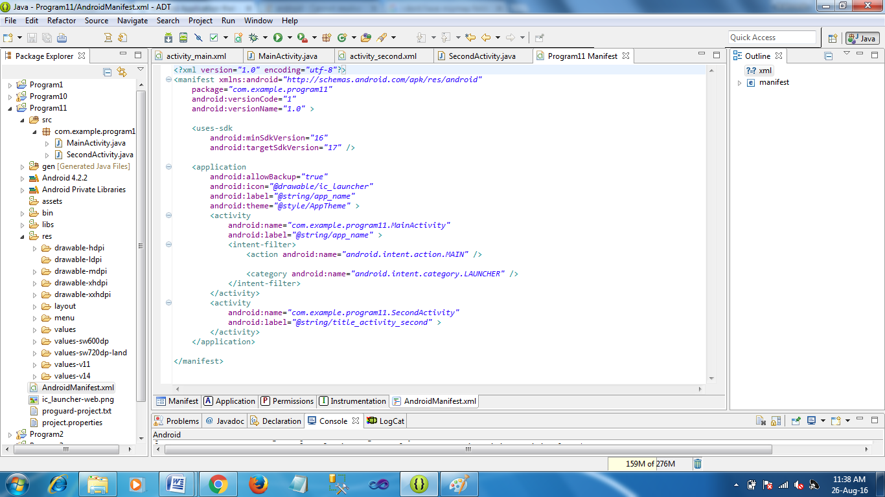

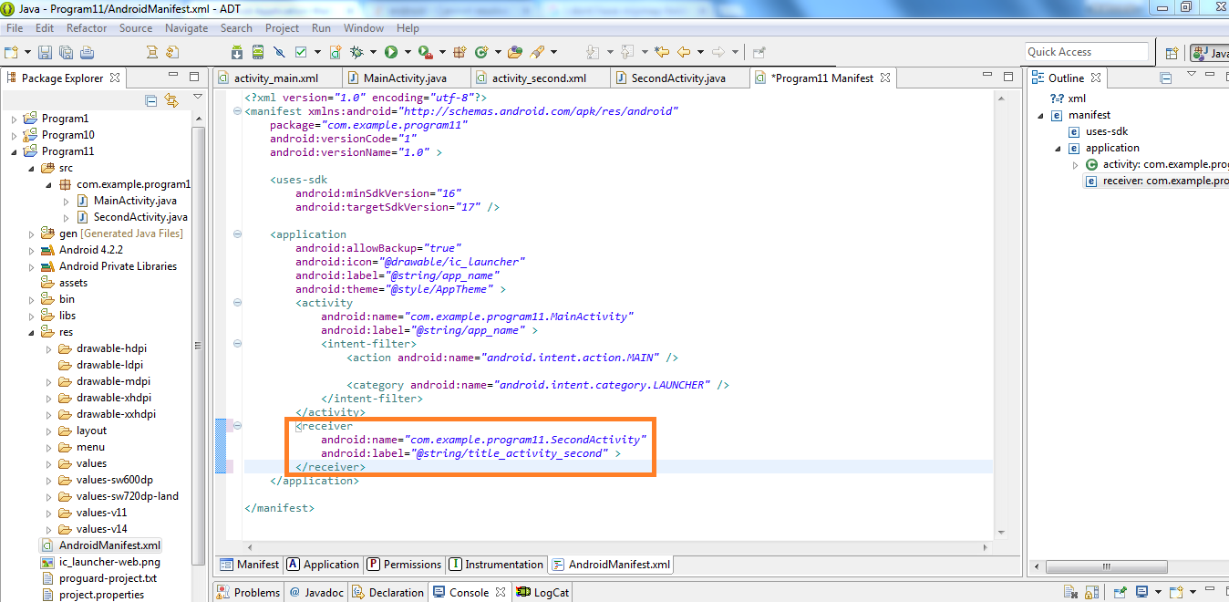

### Java Coding for the Android Application:

#### Java Coding for Main Activity:

* Click on **Program11 -> java -> com.example.Program11 -> MainActivity.**

Code for MainActivity.java

**package** com.example.program11;

**import** java.util.Calendar;

**import** android.widget.ToggleButton;

**import** android.os.Bundle;

**import** android.app.Activity;

**import** android.app.AlarmManager;

**import** android.app.PendingIntent;

**import** android.content.Intent;

**import** android.view.Menu;

**import** android.view.View;

**import** android.widget.TimePicker;

**import** android.widget.Toast;

**public** **class** MainActivity **extends** Activity {

TimePicker alarmTimePicker;

PendingIntent pendingIntent;

AlarmManager alarmManager;

@Override

**protected** **void** onCreate(Bundle savedInstanceState)

{

**super**.onCreate(savedInstanceState);

setContentView(R.layout.*activity_main*);

alarmTimePicker = (TimePicker) findViewById(R.id.*timePicker*);

alarmManager = (AlarmManager) getSystemService(*ALARM_SERVICE*);

}

**public** **void** OnToggleClicked(View view)

{

**long** time;

**if** (((ToggleButton) view).isChecked())

{

Toast.*makeText*(MainActivity.**this**, "ALARM ON", Toast.*LENGTH_SHORT*).show();

Calendar calendar = Calendar.*getInstance*();

calendar.set(Calendar.*HOUR_OF_DAY*, alarmTimePicker.getCurrentHour());

calendar.set(Calendar.*MINUTE*, alarmTimePicker.getCurrentMinute());

Intent intent = **new** Intent(**this**, SecondActivity.**class**);

pendingIntent = PendingIntent.*getBroadcast*(**this**, 0, intent, 0);

time=(calendar.getTimeInMillis()-(calendar.getTimeInMillis()%60000));

**if**(System.*currentTimeMillis*()>time)

{

**if** (calendar.*AM_PM* == 0)

time = time + (1000*60*60*12);

**else**

time = time + (1000*60*60*24);

}

alarmManager.setRepeating(AlarmManager.*RTC_WAKEUP*, time, 10000, pendingIntent);

}

**else**

{

alarmManager.cancel(pendingIntent);

Toast.*makeText*(MainActivity.**this**, "ALARM OFF", Toast.*LENGTH_SHORT*).show();

}

}

}

* So now the Coding part of Main Activity is completed.

#### Java Coding for Second Activity:

* Click on **Program11 -> java -> com.example.Program11 -> SecondActivity.**

**Code for SecondActivity.java:**

**package** com.example.program11;

**import** android.media.Ringtone;

**import** android.content.BroadcastReceiver;

**import** android.media.RingtoneManager;

**import** android.net.Uri;

**import** android.content.Context;

**import** android.content.Intent;

**import** android.widget.Toast;

**public** **class** SecondActivity **extends** BroadcastReceiver {

@Override

**public** **void** onReceive(Context context, Intent intent)

{

Toast.*makeText*(context, "Alarm! Wake up! Wake up!", Toast.*LENGTH_LONG*).show();

Uri alarmUri = RingtoneManager.*getDefaultUri*(RingtoneManager.*TYPE_ALARM*);

**if** (alarmUri == **null**)

{

alarmUri = RingtoneManager.*getDefaultUri*(RingtoneManager.*TYPE_NOTIFICATION*);

}

Ringtone ringtone = RingtoneManager.*getRingtone*(context, alarmUri);

ringtone.play();

}

}

* So now the Coding part of Alarm Receiver is also completed.
* Now run the application to see the output.

Output:

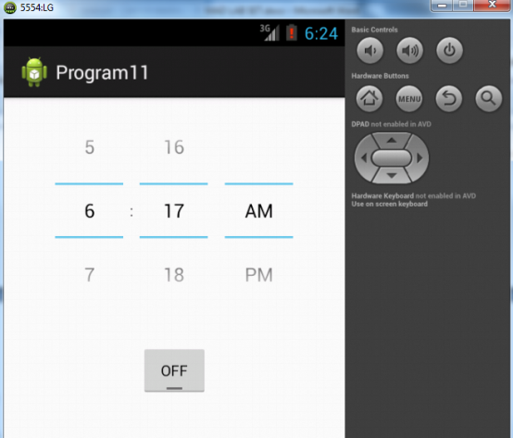

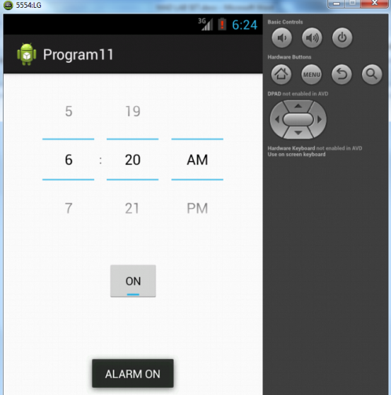

Result:

              Thus Android Application that creates Alarm Clock is developed and executed successfully.

**PROGRAM 9**

Aim:

To develop an Android Application that writes data to the SD Card.

Procedure:

Create Main Activity for the Android Application

**Minimim Required SDK = API 15** and click **Next.**

### Designing layout for the Android Application:

#### Designing Layout for Main Activity:

* Click on **Program9 -> res -> layout -> activity_main.xml.**
* Now go to XML code editor.
* Then delete the code which is there and type the code as given below.

**Code for Activity_main.xml:**

<?xml version=*"1.0"* encoding=*"utf-8"*?>

<LinearLayout xmlns:android=*"http://schemas.android.com/apk/res/android"*

android:layout_width=*"match_parent"*

android:layout_height=*"match_parent"*

android:layout_margin=*"20dp"*

android:orientation=*"vertical"*>

<EditText

android:id=*"@+id/editText"*

android:layout_width=*"match_parent"*

android:layout_height=*"wrap_content"*

android:singleLine=*"true"*

android:textSize=*"30dp"* />

<Button

android:id=*"@+id/button"*

android:layout_width=*"match_parent"*

android:layout_height=*"wrap_content"*

android:layout_margin=*"10dp"*

android:text=*"Write Data"*

android:textSize=*"30dp"* />

<Button

android:id=*"@+id/button2"*

android:layout_width=*"match_parent"*

android:layout_height=*"wrap_content"*

android:layout_margin=*"10dp"*

android:text=*"Read data"*

android:textSize=*"30dp"* />

<Button

android:id=*"@+id/button3"*

android:layout_width=*"match_parent"*

android:layout_height=*"wrap_content"*

android:layout_margin=*"10dp"*

android:text=*"Clear"*

android:textSize=*"30dp"* />

</LinearLayout>

* Now click on **Design** and your application will look as given below.

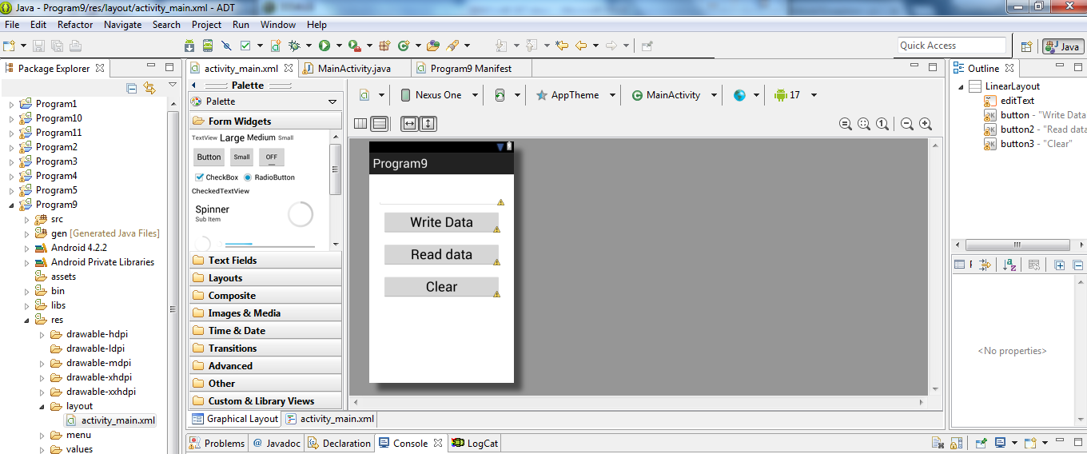

* So now the designing part is completed.

Changes in Manifest for the Android Application:

* Click on **Program9 -> manifests -> AndroidManifest.xml**
* Now go to XML code editor.
* Then delete the code which is there and type the code as given below.

<?xml version=*"1.0"* encoding=*"utf-8"*?>

<manifest xmlns:android=*"http://schemas.android.com/apk/res/android"*

package=*"com.example.program9"*

android:versionCode=*"1"*

android:versionName=*"1.0"* >

<uses-sdk

android:minSdkVersion=*"15"*

android:targetSdkVersion=*"17"* />

<uses-permission android:name=*"android.permission.WRITE_EXTERNAL_STORAGE"*/>

<application

android:allowBackup=*"true"*

android:label=*"@string/app_name"*

android:supportsRtl=*"true"*

android:theme=*"@style/AppTheme"* >

<activity android:name=*".MainActivity"* >

<intent-filter>

<action android:name=*"android.intent.action.MAIN"* />

<category android:name=*"android.intent.category.LAUNCHER"* />

</intent-filter>

</activity>

</application>

</manifest>

### Java Coding for the Android Application:

#### Java Coding for Main Activity:

* Click on **Program9 -> java -> com.example.Program9 -> MainActivity.**

**Code for MainActivity.java**

**package** com.example.program9;

**import** android.os.Bundle;

**import** android.app.Activity;

**import** android.view.View;

**import** android.widget.Button;

**import** android.widget.EditText;

**import** android.widget.Toast;

**import** java.io.BufferedReader;

**import** java.io.File;

**import** java.io.FileInputStream;

**import** java.io.FileOutputStream;

**import** java.io.InputStreamReader;

**public** **class** MainActivity **extends** Activity {

EditText e1;

Button write,read,clear;

@Override

**protected** **void** onCreate(Bundle savedInstanceState)

{

**super**.onCreate(savedInstanceState);

setContentView(R.layout.*activity_main*);

e1= (EditText) findViewById(R.id.*editText*);

write= (Button) findViewById(R.id.*button*);

read= (Button) findViewById(R.id.*button2*);

clear= (Button) findViewById(R.id.*button3*);

write.setOnClickListener(**new** View.OnClickListener()

{

@Override

**public** **void** onClick(View v)

{

String message=e1.getText().toString();

**try**

{

File f=**new** File("/sdcard/myfile.txt");

f.createNewFile();

FileOutputStream fout=**new** FileOutputStream(f);

fout.write(message.getBytes());

fout.close();

Toast.*makeText*(getBaseContext(),"Data Written in SDCARD",Toast.*LENGTH_LONG*).show();

}

**catch** (Exception e)

{

Toast.*makeText*(getBaseContext(),e.getMessage(),Toast.*LENGTH_LONG*).show();

}

}

});

read.setOnClickListener(**new** View.OnClickListener()

{

@Override

**public** **void** onClick(View v)

{

String message;

String buf = "";

**try**

{

File f = **new** File("/sdcard/myfile.txt");

FileInputStream fin = **new** FileInputStream(f);

BufferedReader br = **new** BufferedReader(**new** InputStreamReader(fin));

**while** ((message = br.readLine()) != **null**)

{

buf += message;

}

e1.setText(buf);

br.close();

fin.close();

Toast.*makeText*(getBaseContext(),"Data Recived from SDCARD",Toast.*LENGTH_LONG*).show();

}

**catch** (Exception e)

{

Toast.*makeText*(getBaseContext(), e.getMessage(), Toast.*LENGTH_LONG*).show();

}

}

});

clear.setOnClickListener(**new** View.OnClickListener()

{

@Override

**public** **void** onClick(View v)

{

e1.setText("");

}

});

}

}

* So now the Coding part of Program 9 is also completed.
* Now run the application to see the output.

Output:

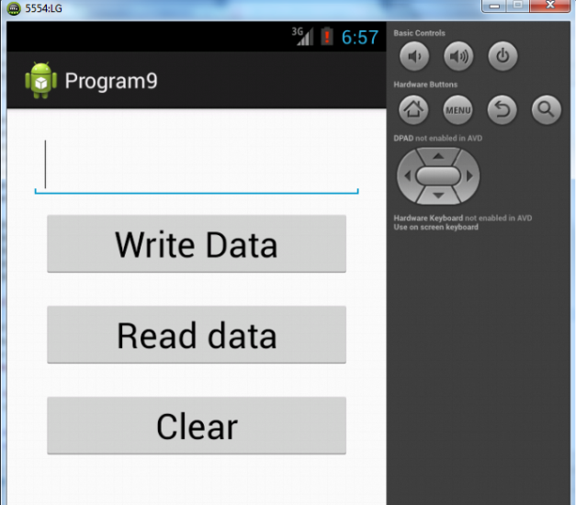

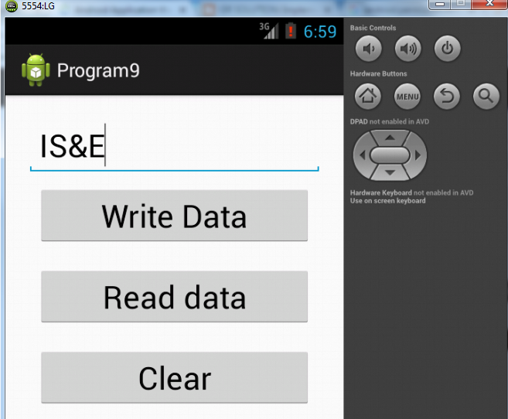

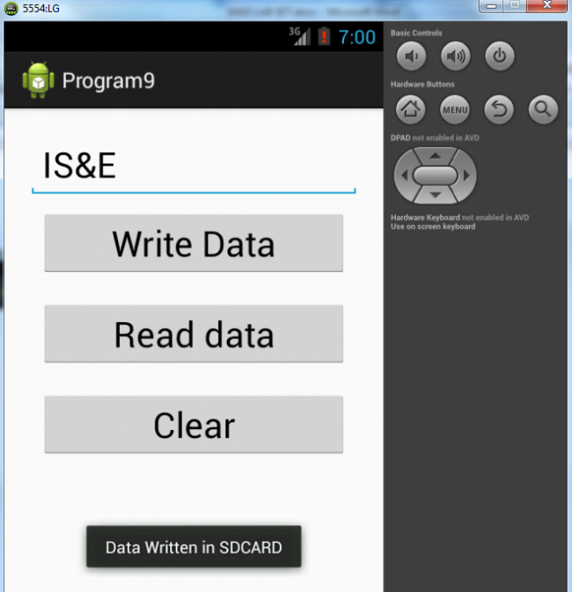

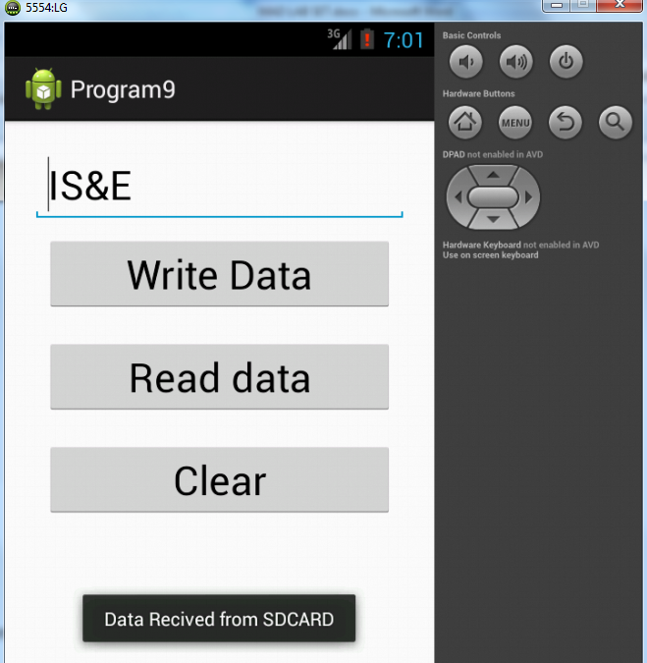

Result:

              Thus Android Application that writes data to the SD Card is developed and executed successfully.

**PROGRAM 7**

Aim:

To build an application that implements multi-threading concept.

Procedure:

Create Main Activity for the Android Application

### Designing layout for the Android Application:

#### Designing Layout for Main Activity:

* Click on **Program7 -> res -> layout -> activity_main.xml.**
* Now go to XML code editor.
* Then delete the code which is there and type the code as given below.

**Code for Activity_main.xml:**

<?xml version=*"1.0"* encoding=*"utf-8"*?>

<LinearLayout xmlns:android=*"http://schemas.android.com/apk/res/android"*

android:layout_width=*"match_parent"*

android:layout_height=*"match_parent"*

android:orientation=*"vertical"*

android:id=*"@+id/info"* >

<Button

android:id=*"@+id/button1"*

android:layout_width=*"match_parent"*

android:layout_height=*"wrap_content"*

android:onClick=*"fetchData"*

android:text=*"Start MULTITHREAD"* />

<TextView

android:id=*"@+id/textView1"*

android:layout_width=*"wrap_content"*

android:layout_height=*"wrap_content"*

android:text=*"Main thread"* />

</LinearLayout>

* Now click on **Design** and your application will look as given below.

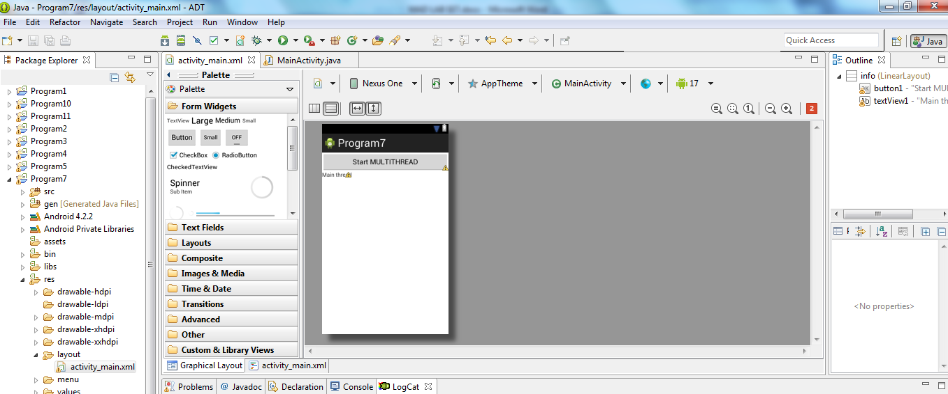

* So now the designing part is completed.

### Java Coding for the Android Application:

#### Java Coding for Main Activity:

* Click on **Program7 -> java -> com.example.Program7 -> MainActivity.**

**Code for MainActivity.java**

**package** com.example.program7;

**import** android.os.Bundle;

**import** android.app.Activity;

**import** android.os.Handler;

**import** android.view.View;

**import** android.widget.TextView;

**public** **class** MainActivity **extends** Activity {

**private** TextView tvOutput;

**private** **static** **final** **int** *t1* = 1;

**private** **static** **final** **int** *t2* = 2;

**private** **static** **final** **int** *t3* = 3;

@Override

**public** **void** onCreate(Bundle savedInstanceState) {

**super**.onCreate(savedInstanceState);

setContentView(R.layout.*activity_main*);

tvOutput = (TextView) findViewById(R.id.*textView1*);

}

**public** **void** fetchData(View v) {

tvOutput.setText("Main thread");

thread1.start();

thread2.start();

thread3.start();

}

Thread thread1 = **new** Thread(**new** Runnable() {

@Override

**public** **void** run() {

**for** (**int** i = 0; i < 5; i++) {

**try** {

Thread.*sleep*(1000);

} **catch** (InterruptedException e) {

e.printStackTrace();

}

handler.sendEmptyMessage(*t1*);

}

}

});

Thread thread2 = **new** Thread(**new** Runnable() {

@Override

**public** **void** run() {

**for** (**int** i = 0; i < 5; i++) {

**try** {

Thread.*sleep*(1000);

} **catch** (InterruptedException e) {

e.printStackTrace();

}

handler.sendEmptyMessage(*t2*);

}

}

});

Thread thread3 = **new** Thread(**new** Runnable() {

@Override

**public** **void** run() {

**for** (**int** i = 0; i < 5; i++) {

**try** {

Thread.*sleep*(1000);

} **catch** (InterruptedException e) {

e.printStackTrace();

}

handler.sendEmptyMessage(*t3*);

}

}

});

Handler handler = **new** Handler() {

**public** **void** handleMessage(android.os.Message msg) {

**if**(msg.what == *t1*) {

tvOutput.append("\nIn thread 1");

}

**if**(msg.what == *t2*) {

tvOutput.append("\nIn thread 2");

}

**if**(msg.what == *t3*) {

tvOutput.append("\nIn thread 3");

}

}

};

}

* So now the Coding part of Program 7 is also completed.
* Now run the application to see the output.

Output:

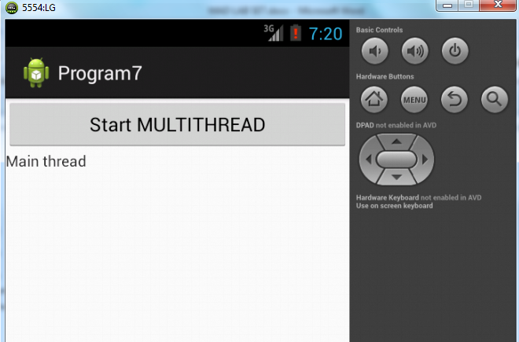

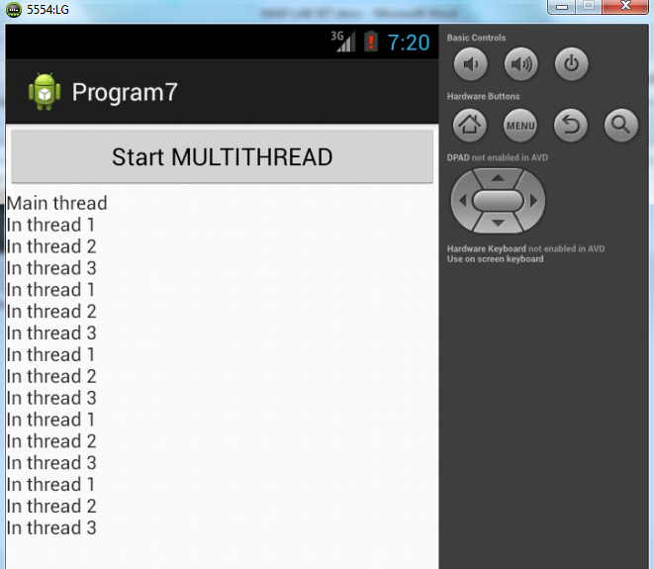

Result:

             Thus Android Application that implements multi-threading concept is developed and executed successfully.

**PROGRAM 8**

Aim:

To develop a native application that uses GPS location information.

Procedure:

Create Main Activity for the Android Application

### Designing layout for the Android Application:

#### Designing Layout for Main Activity:

* Click on **Program8 -> res -> layout -> activity_main.xml.**
* Now go to XML code editor.
* Then delete the code which is there and type the code as given below.

**Code for Activity_main.xml:**

<?xml version=*"1.0"* encoding=*"utf-8"*?>

<RelativeLayout xmlns:android=*"http://schemas.android.com/apk/res/android"*

android:id=*"@+id/relativeLayout1"*

android:layout_width=*"match_parent"*

android:layout_height=*"match_parent"* >

<Button

android:id=*"@+id/button1"*

android:layout_width=*"match_parent"*

android:layout_height=*"wrap_content"*

android:text=*"Show Location"*

/>

</RelativeLayout>

* Now click on **Design** and your application will look as given below.

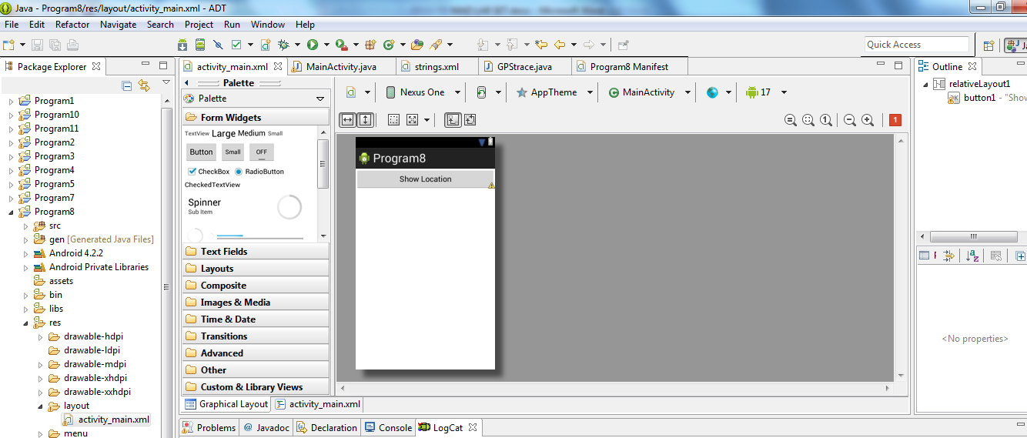

* So now the designing part is completed.

Changes in Manifest for the Android Application:

* Click on **Program8 -> manifests -> AndroidManifest.xml**
* Now go to XML code editor.
* Then delete the code which is there and type the code as given below.

<?xml version=*"1.0"* encoding=*"utf-8"*?>

<manifest xmlns:android=*"http://schemas.android.com/apk/res/android"*

package=*"com.example.program8"*

android:versionCode=*"1"*

android:versionName=*"1.0"* >

<uses-sdk

android:minSdkVersion=*"8"*

android:targetSdkVersion=*"17"* />

**<uses-permission**

**android:name=*"android.permission.ACCESS_FINE_LOCATION"*/>**

**<uses-permission**

**android:name=*"android.permission.INTERNET"*/>**

<application

android:allowBackup=*"true"*

android:icon=*"@drawable/ic_launcher"*

android:label=*"@string/app_name"*

android:theme=*"@style/AppTheme"* >

<activity

android:name=*"com.example.program8.MainActivity"*

android:label=*"@string/app_name"* >

<intent-filter>

<action android:name=*"android.intent.action.MAIN"* />

<category android:name=*"android.intent.category.LAUNCHER"* />

</intent-filter>

</activity>

</application>

</manifest>

### Java Coding for the Android Application:

#### Java Coding for Main Activity:

* Click on **Program8 -> java -> com.example.Program8 -> MainActivity.**

**Code for MainActivity.java**

**package** com.example.program8;

**import** android.os.Bundle;

**import** android.app.Activity;

**import** android.view.View;

**import** android.widget.Button;

**import** android.widget.Toast;

**public** **class** MainActivity **extends** Activity {

/** Called when the activity is first created. */

Button btnShowLocation;

GPStrace gps;

@Override

**public** **void** onCreate(Bundle savedInstanceState) {

**super**.onCreate(savedInstanceState);

setContentView(R.layout.*activity_main*);

btnShowLocation=(Button)findViewById(R.id.*button1*);

btnShowLocation.setOnClickListener(**new** View.OnClickListener() {

@Override

**public** **void** onClick(View v) {

// **TODO** Auto-generated method stub

gps=**new** GPStrace(MainActivity.**this**);

**if**(gps.canGetLocation()){

**double** latitude=gps.getLatitude();

**double** longitude=gps.getLongtiude();

Toast.*makeText*(getApplicationContext(),"Your Location is \nLat:"+latitude+"\nLong:"+longitude, Toast.*LENGTH_LONG*).show();

}

**else**

{

gps.showSettingAlert();

}

}

});

}

}

Create one more Java class file Named as “GPStrace.java” in the same package as shown below

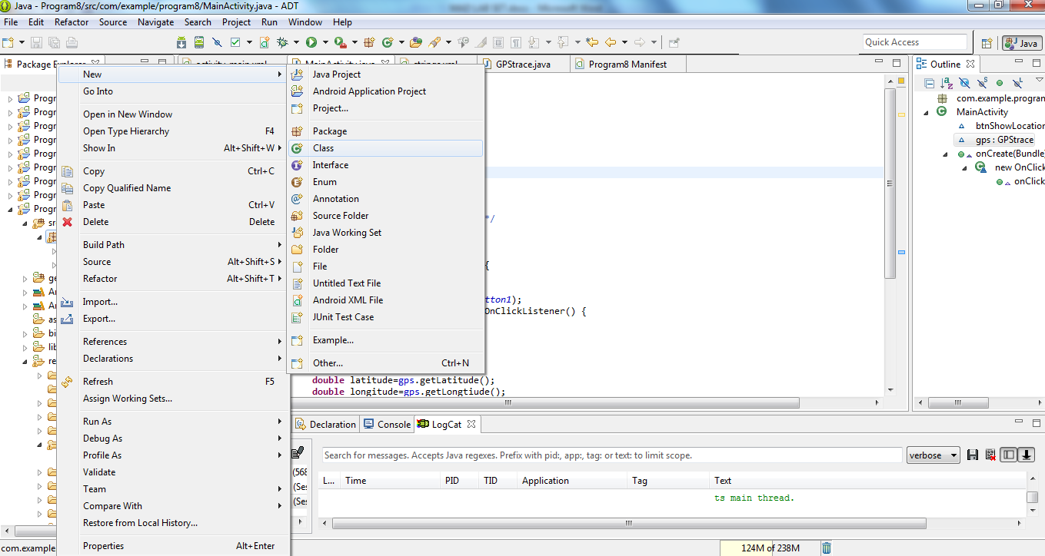

**Code for GPStrace.java**

**package** com.example.program8;

**import** android.app.AlertDialog;

**import** android.app.Service;

**import** android.content.Context;

**import** android.content.DialogInterface;

**import** android.content.Intent;

**import** android.location.Location;

**import** android.location.LocationListener;

**import** android.location.LocationManager;

**import** android.os.Bundle;

**import** android.os.IBinder;

**import** android.provider.Settings;

**public** **class** GPStrace **extends** Service **implements** LocationListener{

**private** **final** Context context;

**boolean** isGPSEnabled=**false**;

**boolean** canGetLocation=**false**;

**boolean** isNetworkEnabled=**false**;

Location location;

**double** latitude;

**double** longtitude;

**private** **static** **final** **long** *MIN_DISTANCE_CHANGE_FOR_UPDATES*=10;

**private** **static** **final** **long** *MIN_TIME_BW_UPDATES*=1000*60*1;

**protected** LocationManager locationManager;

**public** GPStrace(Context context)

{

**this**.context=context;

getLocation();

}

**public** Location getLocation()

{

**try**{

locationManager=(LocationManager) context.getSystemService(*LOCATION_SERVICE*);

isGPSEnabled=locationManager.isProviderEnabled(LocationManager.*GPS_PROVIDER*);

isNetworkEnabled=locationManager.isProviderEnabled(LocationManager.*NETWORK_PROVIDER*);

**if**(!isGPSEnabled && !isNetworkEnabled){

}**else**{

**this**.canGetLocation=**true**;

**if**(isNetworkEnabled){

locationManager.requestLocationUpdates(

LocationManager.*NETWORK_PROVIDER*,

*MIN_TIME_BW_UPDATES*,

*MIN_DISTANCE_CHANGE_FOR_UPDATES*,**this**);

}

**if**(locationManager!=**null**){

location=locationManager.getLastKnownLocation(LocationManager.*NETWORK_PROVIDER*);

**if**(location !=**null**){

latitude=location.getLatitude();

longtitude=location.getLongitude();

}

}

}

**if**(isGPSEnabled){

**if**(location==**null**){

locationManager.requestLocationUpdates(LocationManager.*GPS_PROVIDER*,*MIN_TIME_BW_UPDATES*, *MIN_DISTANCE_CHANGE_FOR_UPDATES*, **this**);

**if**(locationManager!=**null**){

location=locationManager.getLastKnownLocation(LocationManager.*GPS_PROVIDER*);

**if**(location!=**null**){

latitude=location.getLatitude();

longtitude=location.getLongitude();

}

}

}

}

}

**catch**(Exception e)

{

e.printStackTrace();

}

**return** location;

}

**public** **void** stopUsingGPS(){

**if**(locationManager!=**null**){

locationManager.removeUpdates(GPStrace.**this**);

}

}

**public** **double** getLatitude(){

**if**(location!=**null**){

latitude=location.getLatitude();

}

**return** latitude;

}

**public** **double** getLongtiude(){

**if**(location!=**null**){

longtitude=location.getLatitude();

}

**return** longtitude;

}

**public** **boolean** canGetLocation(){

**return** **this**.canGetLocation;

}

**public** **void** showSettingAlert(){

AlertDialog.Builder alertDialog=**new** AlertDialog.Builder(context);

alertDialog.setTitle("GPS is settings");

alertDialog.setMessage("GPS is not enabled.Do you want to go to setting menu?");

alertDialog.setPositiveButton("settings", **new** DialogInterface.OnClickListener() {

@Override

**public** **void** onClick(DialogInterface dialog,**int** which){

Intent intent=**new** Intent(Settings.*ACTION_LOCATION_SOURCE_SETTINGS*);

context.startActivity(intent);

}

});

alertDialog.setNegativeButton("cancel", **new** DialogInterface.OnClickListener() {

@Override

**public** **void** onClick(DialogInterface dialog, **int** which) {

// **TODO** Auto-generated method stub

dialog.cancel();

}

});

alertDialog.show();

}

@Override

**public** **void** onLocationChanged(Location location) {

// **TODO** Auto-generated method stub

}

@Override

**public** **void** onProviderDisabled(String provider) {

// **TODO** Auto-generated method stub

}

@Override

**public** **void** onProviderEnabled(String provider) {

// **TODO** Auto-generated method stub

}

@Override

**public** **void** onStatusChanged(String provider, **int** status, Bundle extras) {

// **TODO** Auto-generated method stub

}

@Override

**public** IBinder onBind(Intent intent) {

// **TODO** Auto-generated method stub

**return** **null**;

}

}

* So now the Coding part of Program 8 is also completed.
* Now run the application to see the output.

Output:

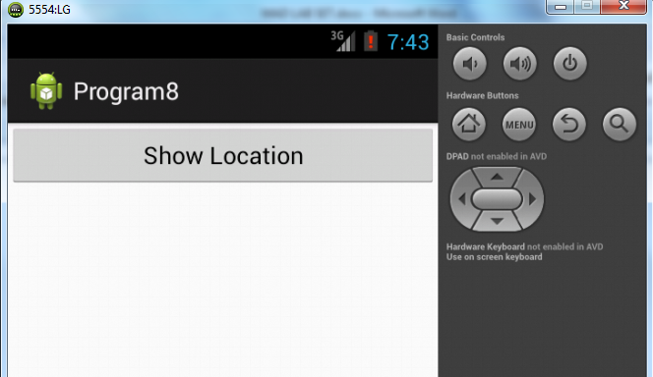

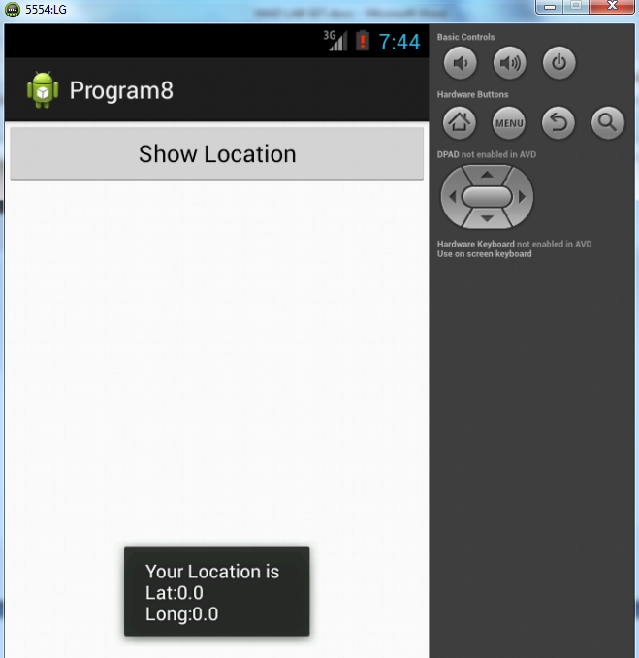

Result:

              Thus Android Application that uses GPS location information is developed and executed successfully.

http://www.codingconnect.net/android-application-for-layout-managers-event-listners/